SUSTAINABILITY SURVEY: CONSUMER SUSTAINABLE BEHAVIOR INDEX (CSBI)
Summary of main results

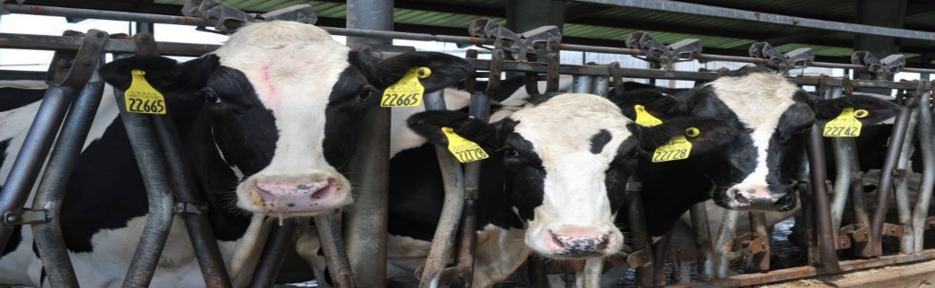

DECEMBER 2021

Participant organizations: Altroconsumo (Italy), Consumentenbond (The Netherlands), Danish Consumer Council (Denmark), Deco Proteste (Portugal), D-Test (Czech Republic), OCU (Spain), Protégez-vous (Canada), RusQuality (Russia), Stiftung Warentest (Germany), Test-Achats/Test-Ankoop (Belgium), UFC-Que Choisir (France), VKI (Austria), Which (UK), ZPS (Slovenia)

DISCLAIMER: The content of this report is the property of ICRT, BEUC and the participant organizations. The methodology and questionnaire should not be applied to any other research or projects

TABLE OF CONTENTS

EXECUTIVE SUMMARY 2
1.1 DELPHI RESEARCH 2
1.2 COMMUNITY SURVEYS 4
1.3 COUNTRY RESULTS 8
1.3.1 Austria 8
1.3.2 Belgium 12
1.3.3 Canada 16
1.3.4 Czech Republic 20
1.3.5 Denmark 24
1.3.6 France 28
1.3.7 Germany 32
1.3.8 Italy 36
1.3.9 Portugal 40
1.3.10 Russia 44
1.3.11 Slovenia 48
1.3.12 Spain 51
1.3.13 The Netherlands 56
1.3.14 UK 60

EXECUTIVE SUMMARY

The research had 2 goals:
- Creating a tool/questionnaire to measure the Consumer Sustainable Behavior Index (CSBI), based on the feedback/consensus of different sustainability experts
- Once the index is created, applying this questionnaire through community surveys to consumers in the participating countries

DELPHI RESEARCH
To develop the CSBI, a DELPHI methodology has been applied.
DELPHI is a method for structuring group communication processes so that they are effective in allowing a group of experts to deal with a research question. This is done through rounds of questionnaires where panelists are asked to give their opinion on different issues, until a consensus is reached.

These main aspects have been researched in 5 main dimensions our consumers associations have been working on:
- Food
- Travel and mobility
- Water and energy in the household
- Purchase of products (non-food) and services
- Waste management

The main research question for this DELPHI methodology was: what are the main aspects that an CSBI should include to measure sustainability of consumer related behavior?

Experts participating (39 answered at least for one round) in this DELPHI research process had different backgrounds related with sustainability (consumer and sustainability activist, academia, public sector, think tanks, etc.). Their answers were weighted according to their self-assesed level of expertise in the different dimensions, years of experience and number of international projects in the field of sustainability.
The following table shows the final CSBI coming from the feedback of the experts, including the 5 behaviors that were considered as the most important for each of the dimensions, and also the importance/weight of each dimension and each behavior in the CSBI.

Food dimension | Behaviors
 | Reducing meat, dairy and animal products: having a vegetarian/vegan diet, favoring a plant-based diet, eating less (red) meat
 | Avoiding/reducing food waste: avoiding buying too much, buying/preparing only the amount of food that you need
 | Buying seasonal food, with the closest origin as possible (km. 0, local, regional, from your own country, avoiding exotic foods
 | Buying food products with sustainability labels (e.g.: organic/ecological, fair trade, sustainability, etc.)
 | Avoiding/reducing packaging: buying bulk food, preferring food with no packaging or less packaging as possible
 | Full dimension
Travel and mobility dimension | Behaviors
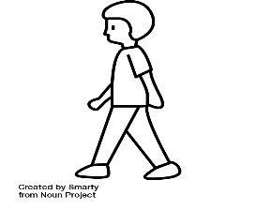 | Walking, going by bicycle (and similar means of transport) and using public transport in everyday mobility
 | Avoiding/reducing flying for other less polluting means of transport (e.g.: when possible, going by train instead of flying
 | Not having a car (e.g.: renting it or using car sharing/pooling when necessary)
 | If having a car, using it only when necessary and choosing a low emission car (e.g.: fully electric)
 | Following sustainable tourism practices: avoiding cruise ships, buying local foods and products in the destination, staying
 | Full dimension
Water and energy in the household | Behaviors
 | Introducing/improving insulation at home: of buildings, walls, roof, windows, etc.
 | Energy saving behaviors in the household: avoiding overuse of air conditioning and heating, turning stand-by and lights off…
 | Having energy and water efficient/saving household appliances and devices, lighting and heating systems
 | Producing your own energy: solar panels, PV…
 | Having a green/renewable energy provider
 | Full dimension
Purchase of (non-food) products and services | Behaviors
 | Reducing/avoiding (over)consumption, buying as less as possible, adapted to the real needs
 | Preferring products of better quality/reliable/long lasting/that can be repaired
 | Avoiding buying single use products (e.g.: diapers, razors)
 | Buying products/services with sustainability labels
 | Buying products and services and investing in sustainable companies
 | Full dimension
Waste management | Behaviors
Waste management | Reusing products as much as possible, doing a good maintenance of them in order to prolong its life cycle
 | Repairing products as much as possible instead of buying new ones
 | Donating, sharing, and selling products second hand
 | Avoiding/reducing packaging; buying products without packaging or as little of it as possible
 | Recycling properly: separating waste correctly, collecting the right information on how to do it correctly…
 | Full dimension

COMMUNITY SURVEYS
CSBI OVERALL RESULTS
The CSBI was applied to national representative surveys (around 1000 answers per country) in the 14 participant countries. Below the overall result:
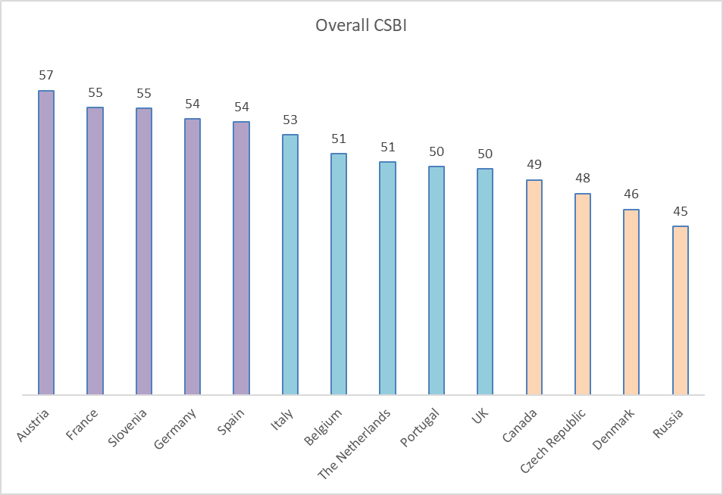

Above the average
On the average
Below the average

Austria, France, Slovenia, Germany and Spain show obtain results above the average of the participant countries for the CSBI

Italy, Belgium, The Netherlands, and Portugal are on the average of the participant countries

Canada, Czech Repulbic, Denmark and Russia obtain results below the average of the participant countries

Results of the CSBI for the FOOD dimension:
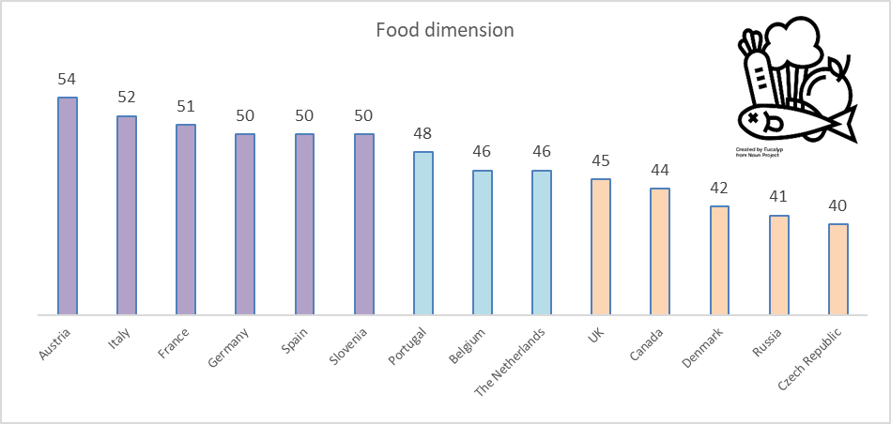
Above the average
On the average
Below the average
Results of the CSBI for the TRAVEL AND MOBILITY dimension:
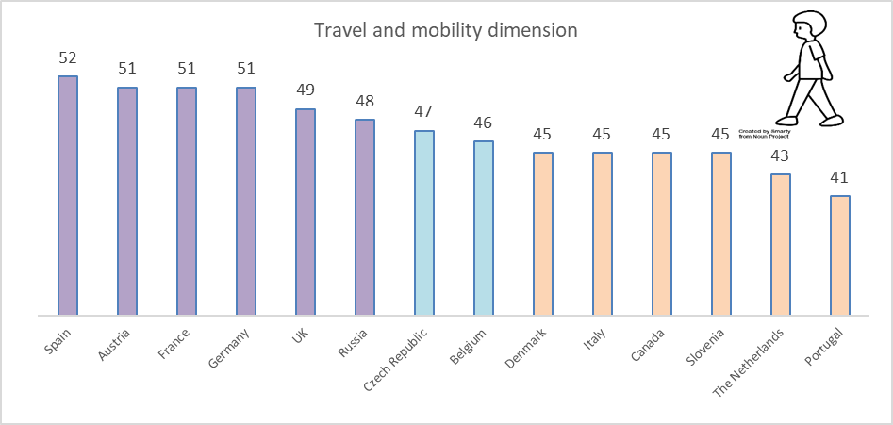
Above the average
On the average
Below the average

Results of the CSBI for the WATER AND ENERGY IN THE HOUSEHOLD dimension:
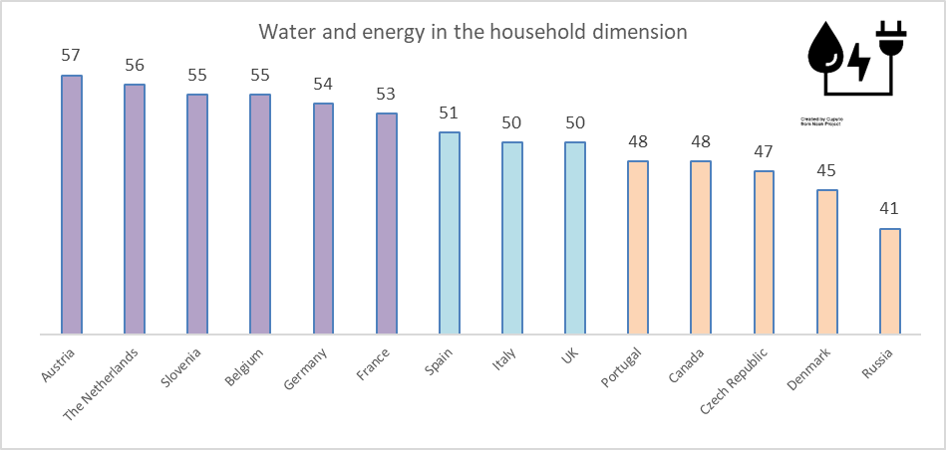
Above the average
On the average
Below the average
Results of the CSBI for the PURCHASE OF (NON-FOOD) PRODUCTS AND SERVICES dimension:
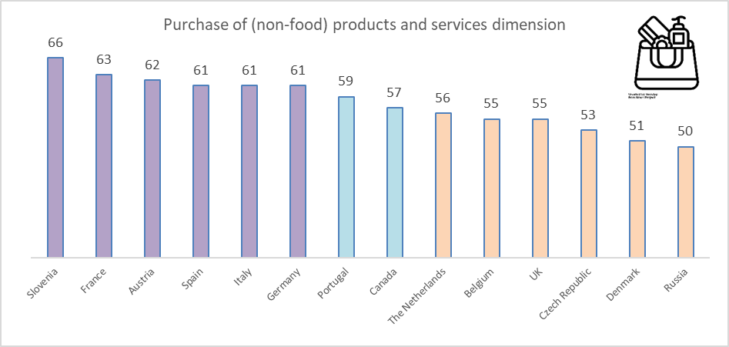
Above the average
On the average
Below the average

Results of the CSBI for the WASTE MANAGEMENT dimension:
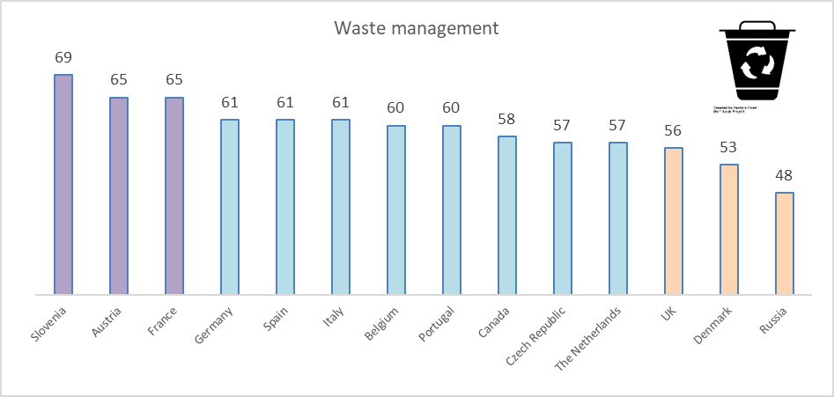
Above the average
On the average
Below the average

COUNTRY RESULTS

Austria
CSBI results
Austria obtains the following scores in the CSBI
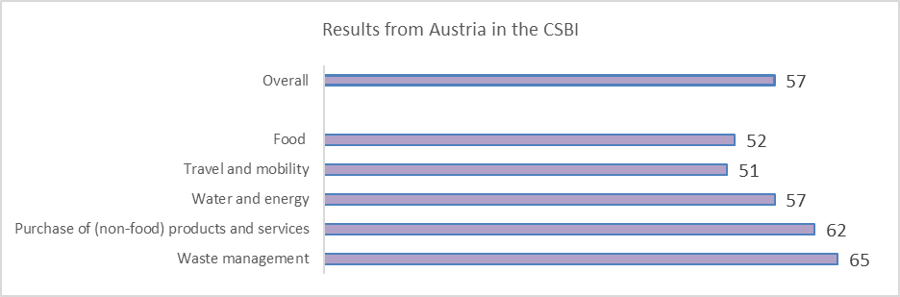
Above the average
On the average
Below the average

Austria scores above the average overall and for all dimensions. The most important sociodemopraphics variable for explaining the differences in the CSBI is age. Female respondents above 50 years old score the highest in the CSBI (61). Respondents 50 years old and younger with a medium/low educational level score the lowest in the CSBI (54).

Below some relevant data on the behavior of Austrians by dimension:

- 2% of respondents describe themselves as vegan and 5% as vegetarian, whereas 28% eat animal products without trying to reduce its consumption

- 32% follow the behavior of trying to reduce food waste “almost completely”. On the contrary, 5% do not follow this behavior “at all” or “only little”
- 24% of respondents follow the behavior “mainly walking, use the bicycle and/or public transport in daily mobility “(almost) completely”

- 52% try to avoid flying “a lot” or “almost completely”
- 1 out of 4 respondents consider that they have, almost completely, a well insulated home

- In relation to having energy saving habits in the household, 3% follow this behavior “not at all” and 8% “little”
- 18% reduces/avoids overconsumption “almost completely”, whereas 11% “not at all” or “little”

- 69% prefers products that are of better quality, long lasting, and that can be repaired (“almost completely”+ “a lot”)
- 34% follows the behavior reusing products as long as possible “almost completely”

- For repairing products as much as possible instead of buying new ones, 10% do it “not at all” or “little”, whereas 22% “almost completely”

Importance attributed to dimensions and behaviors: comparisons
The following graph shows the importance (position) attributed to the dimensions included in the research in relation to their impact on sustainability: by Austrian respondents and in the survey overall and by experts in the DELPHI research:
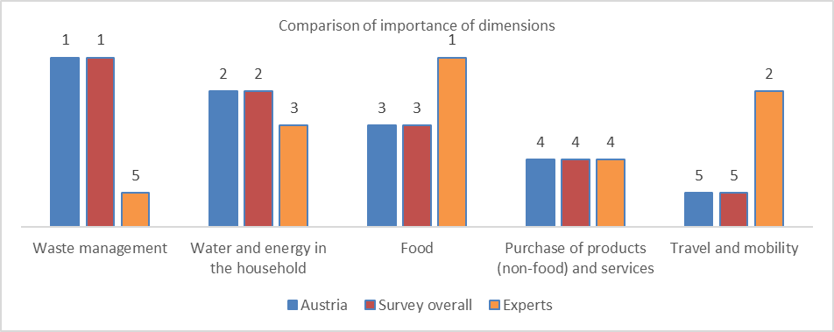

Austrian respondents consider “waste management” as the most important dimension, followed by “water and energy in the household”, “food”, “purchase of products…” and “travel and mobility”.There are no differences whatsoever between Austrian respondents and the survey overall.
However, Austrian respondents differ significantly from expert’s opinion. Most important differences:

- “Waste management” is the most important dimension for Austrians and the least important for experts
- “Travel and mobility” is the least important for Austrians and the second for experts. Austrians consider that “not having a car” is the least important behavior for the dimension, whereas for experts is the third; only 28% of Austrians consider this behavior of “(very) high importance” for sustainability
- “Food” takes the third position in importance for Austrians, whereas for experts is the most important dimension in relation to its impact on sustainability. Austrians consider that the behavior “following a plant-based diet” is the least important, whereas for experts is the most important; 33% of Austrians consider it of “(very) low importance” for sustainability.

Perceived level of information, sustainability of the own behavior and importance attributed to having a sustainable behavior

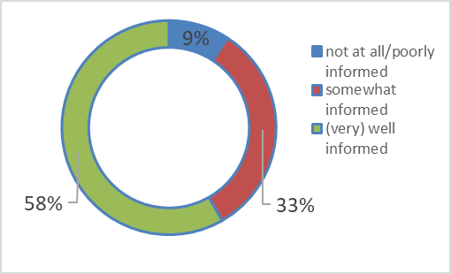
- Highest percentage of (very) well informed for “waste management”: 75%

- Lowest percentage of (very) well informed for “purchase of (non) food products and services”: 53%

- Those who feel overall (very) well informed score higher (61) in the CSBI than those who feel not at all/poorly informed (46)

Overall perceived information about sustainability

- For “waste management”, the percentage of those with a behavior a lot/almost completely sustainable is the highest: 75%

- For “purchase of (non) food products and services”, the lowest: 44%

- Those who perceive themselves as behaving more sustainably score higher (63) in the CSBI than those with a lower perception of sustainability in the own behavior (40)

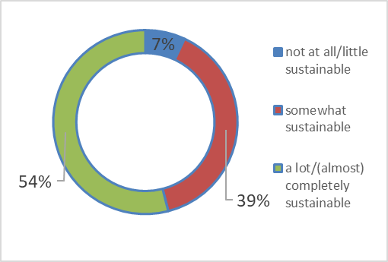
Perceived sustainability of the own behavior

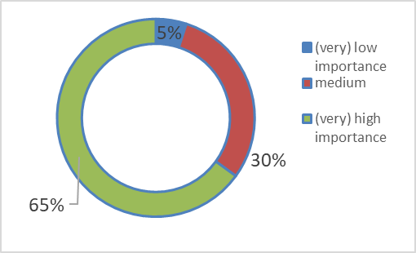
- Highest percentage of (very) high importance for “waste management”: 78%

- Lowest percentage of (very) high importance for “travel and mobility”: 49%

- Those who attribute a (very) high importance score higher (61) in the CSBI than those who attribute a (very) low importance (38)

Importance attributed to a personal sustainable behavior

Most important barriers to have a (more) sustainable behavior by dimension
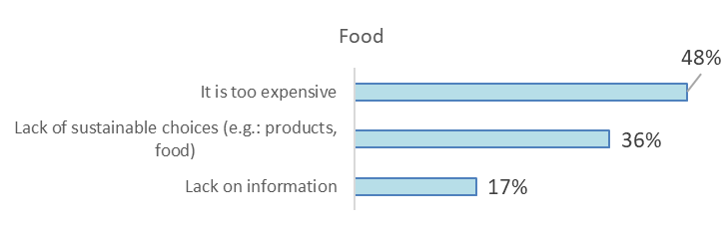
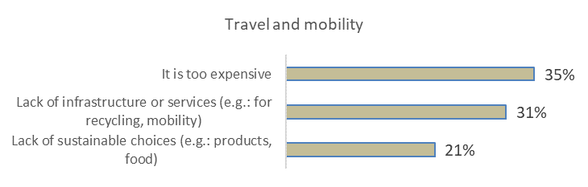

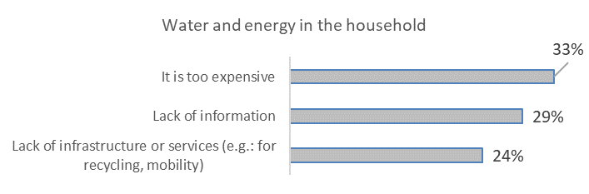

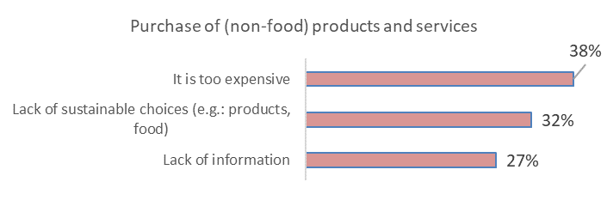

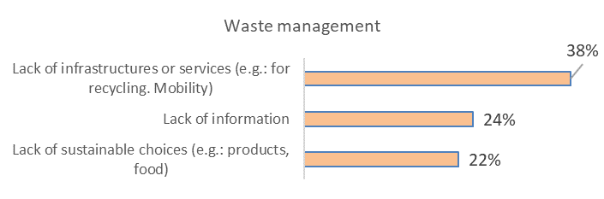

Belgium
CSBI results
Belgium obtains the following scores in the CSBI
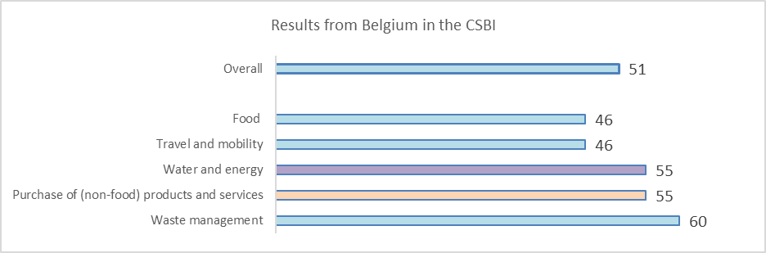
Above the average
On the average
Below the average

Belgium scores above the average in the water and energy dimension. The most important sociodemopraphics variable for explaining the differences is educational level.
Respondents with a high educational level score the highest in the CSBI (53).
Male respondents with a low/medium educational score the lowest in the CSBI (49).

Below some relevant data on the behavior of Belgians by dimension:

- 1% of respondents describe themselves as vegan and 2% as vegetarian, whereas 39% eat animal products without trying to reduce its consumption

- 27% follow the behavior of trying to reduce food waste “almost completely”. On the contrary, 8% do not follow this behavior “at all” or “only little”

- 19% of respondents follow the behavior “mainly walking, use the bicycle and/or public transport in daily mobility “(almost) completely”

- 43% try to avoid flying “a lot” or “almost completely”
- 13% consider that they have, almost completely, a well insulated home

- In relation to having energy saving habits in the household, 3% follow this behavior “not at all” and 9% “little”

- 15% reduces/avoids overconsumption “almost completely”, whereas 13% “not at all” or “little”

- 54% prefers products that are of better quality, long lasting, and that can be repaired (“almost completely”+ “a lot”)

- 31% follows the behavior reusing products as long as possible “almost completely”

- For repairing products as much as possible instead of buying new ones, 17% do it “not at all” or “little”, whereas 16% “almost completely”

Importance attributed to dimensions and behaviors: comparisons
The following graph shows the importance (position) attributed to the dimensions included in the research in relation to their impact on sustainability: by Belgian respondents and in the survey overall and by experts in the DELPHI research:
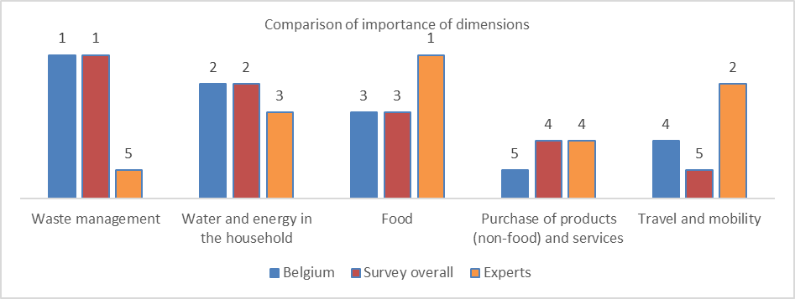

Belgian respondents consider “waste management” as the most important dimension, followed by “water and energy in the household”, “food”, “travel and mobility” and “purchase of products…”. Differences between Belgians respondents and survey overall are minor: only one position more for “travel and mobility” and one less for “purchase of products…”.
However, Belgians respondents differ significantly from expert’s opinion. Most important differences:

- “Waste management” is the most important dimension for Belgians and the least important for experts

- “Travel and mobility” takes the 4th position in importance for Belgians and the second for experts. Belgians consider that “not having a car” is the least important behavior for the dimension, whereas for experts is the third; only 33% of Belgians consider this behavior of “(very) high importance” for sustainability

- “Food” takes the third position in importance for Belgians, whereas for experts is the most important dimension in relation to its impact on sustainability. Belgians consider that the behavior “following a plant-based diet” is the least important, whereas for experts is the most important; 42% of Belgians consider it of “(very) low importance” for sustainability.
Perceived level of information, sustainability of the own behavior and importance attributed to having a sustainable behavior
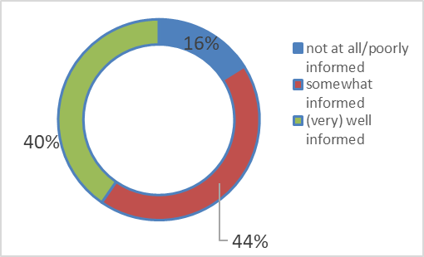
- Highest percentage of (very) well informed for “waste management”: 59%

- Lowest percentage of (very) well informed for “purchase of (non) food products and services”: 39%

- Those who feel overall (very) well informed score higher (57) in the CSBI than those who feel not at all/poorly informed (41)

Overall perceived information about sustainability

- For “waste management”, the percentage of those with a behavior a lot/almost completely sustainable is the highest: 67%

- For “purchase of (non) food products and services”, the lowest: 39%

- Those who perceive themselves as behaving more sustainably score higher (58) in the CSBI than those with a lower perception of sustainability in the own behavior (35)

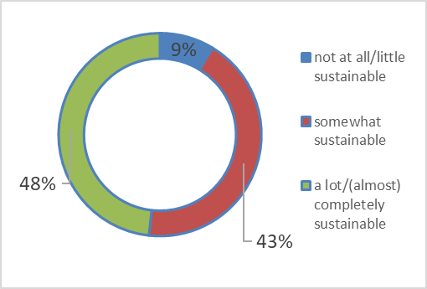
Perceived sustainability of the own behavior

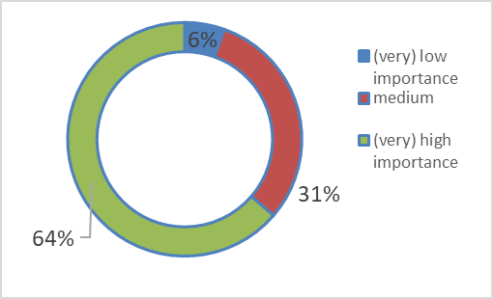
- Highest percentage of (very) high importance for “waste management”: 74%

- Lowest percentage of (very) high importance for “travel and mobility”: 53%

- Those who attribute a (very) high importance score higher (56) in the CSBI than those who attribute a (very) low importance (34)

Importance attributed to a personal sustainable behavior

Most important barriers to have a (more) sustainable behavior by dimension
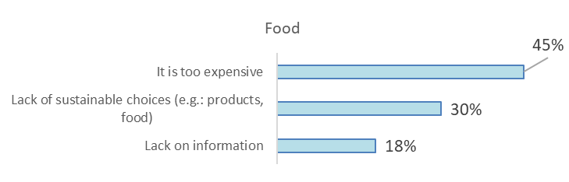
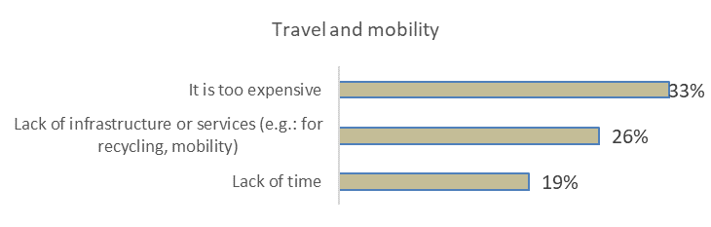

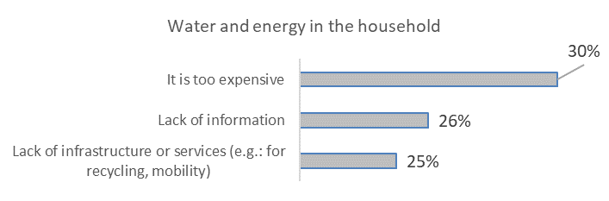

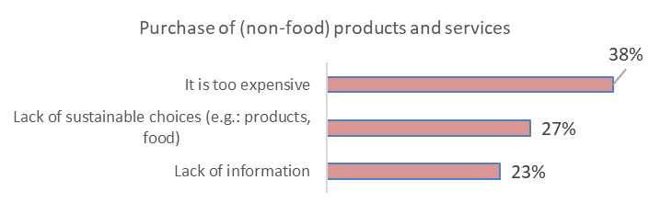

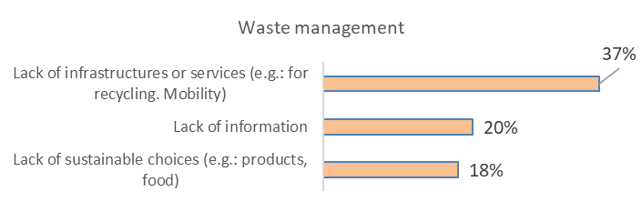

Canada
CSBI results
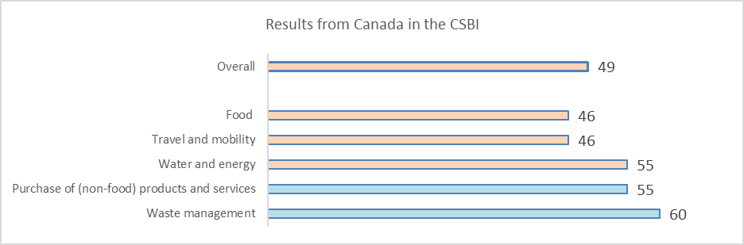
Above the average
On the average
Below the average

Canada scores below the average overall and on the average on “purchase of products…” and “waste management”. The most important variable for explaining the differences is region.
Respondents in Quebec score the highest in the CSBI (53).
Respondents in Atlantic, Newfoundland and Labrador, Prince Edward Island, Nova Scotia, New Brunswick, Northern Canada, Yukon, Northwest Territories, Nunavut, Prairies, Alberta, Saskatchewan and Manitoba score the lowest in the CSBI. (46)

Below some relevant data on the behavior of Canadians by dimension:

- 2% of respondents describe themselves as vegan and 2% as vegetarian, whereas 45% eat animal products without trying to reduce its consumption

- 25% follow the behavior of trying to reduce food waste “almost completely”. On the contrary, 12% do not follow this behavior “at all” or “only little”

- 17% of respondents follow the behavior “mainly walking, use the bicycle and/or public transport in daily mobility “(almost) completely”

- 39% try to avoid flying “a lot” or “almost completely”
- 17% consider that they have, almost completely, a well insulated home

- In relation to having energy saving habits in the household, 4% follow this behavior “not at all” and 8% “little”
- 16% reduces/avoids overconsumption “almost completely”, whereas 19% “not at all” or “little”

- 54% prefers products that are of better quality, long lasting, and that can be repaired (“almost completely”+ “a lot”)

- 28% follows the behavior reusing products as long as possible “almost completely”

- For repairing products as much as possible instead of buying new ones, 18% do it “not at all” or “little”, whereas 19% “almost completely”

Importance attributed to dimensions and behaviors: comparisons
The following graph shows the importance (position) attributed to the dimensions included in the research in relation to their impact on sustainability: by Canadian respondents and in the survey overall and by experts in the DELPHI research:

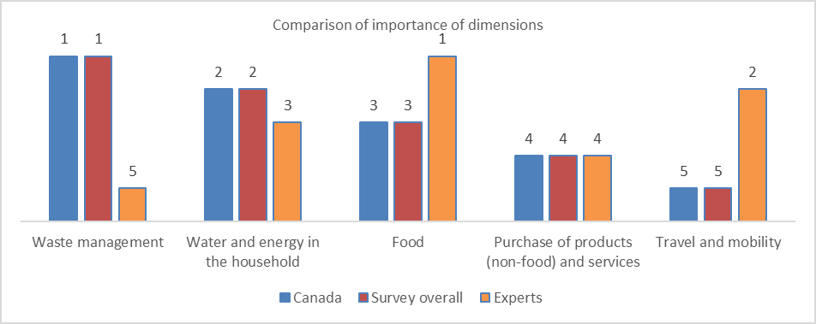

Canadian respondents consider “waste management” as the most important dimension, followed by “water and energy in the household”, “food”, “purchase of products…” and “travel and mobility”.There are no differences whatsoever between Canadian respondents and the survey overall.
However, Canadian respondents differ significantly from expert’s opinion. Most important differences:

- “Waste management” is the most important dimension for Canadians and the least important for experts
- “Travel and mobility” is the least important for Canadians and the second for experts. Canadians consider that “not having a car” is the least important behavior for the dimension, whereas for experts is the third; only 31% of Canadians consider this behavior of “(very) high importance” for sustainability
- “Food” takes the third position in importance for Canadians, whereas for experts is the most important dimension in relation to its impact on sustainability. Canadians consider that the behavior “following a plant-based diet” is the least important, whereas for experts is the most important; 49% of Canadians consider it of “(very) low importance” for sustainability.
Perceived level of information, sustainability of the own behavior and importance attributed to having a sustainable behavior

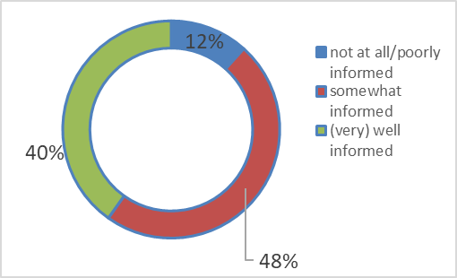
Overall perceived information about sustainability
- Highest percentage of (very) well informed for “waste management”: 56%

- Lowest percentage of (very) well informed for “travel and mobility”: 42%

- Those who feel overall (very) well informed score higher (56) in the CSBI than those who feel not at all/poorly informed (37)

- For “waste management”, the percentage of those with a behavior a lot/almost completely sustainable is the highest: 56%

- For “purchase of (non) food products and services”, the lowest: 40%

- Those who perceive themselves as behaving more sustainably score higher (57) in the CSBI than those with a lower perception of sustainability in the own behavior (37)

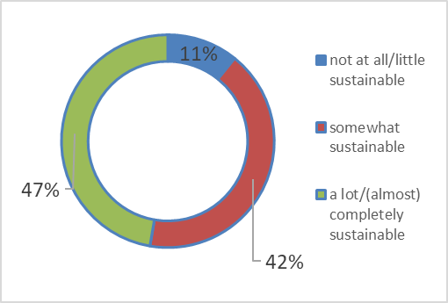
Perceived sustainability of the own behavior

(Table 145, page 153)
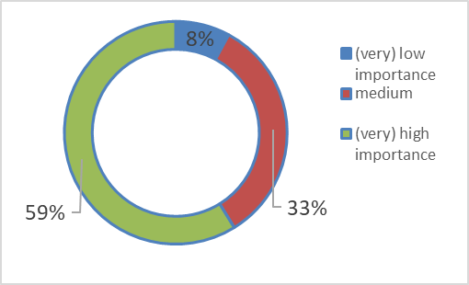
- Highest percentage of (very) high importance for “waste management”: 63%

- Lowest percentage of (very) high importance for “travel and mobility”: 45%

- Those who attribute a (very) high importance score higher (56) in the CSBI than those who attribute a (very) low importance (30)

Importance attributed to a personal sustainable behavior

Most important barriers to have a (more) sustainable behavior by dimension
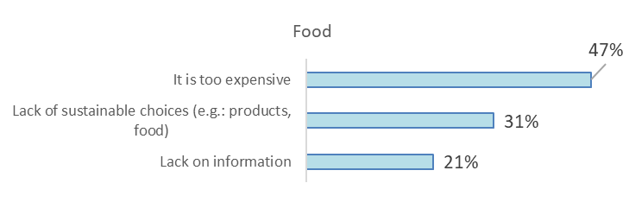

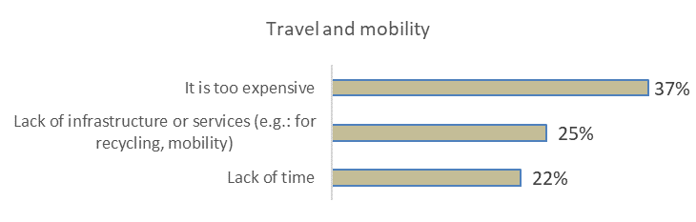

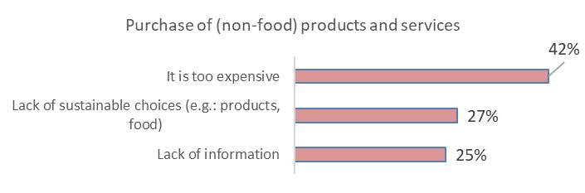
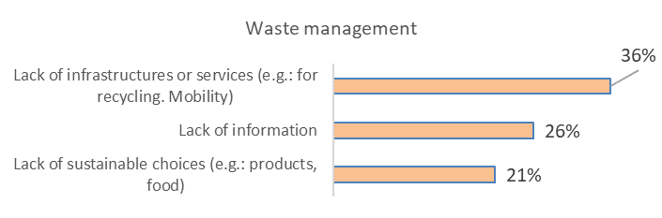

Czech Republic
CSBI results
Czech Republic obtains the following scores in the CSBI
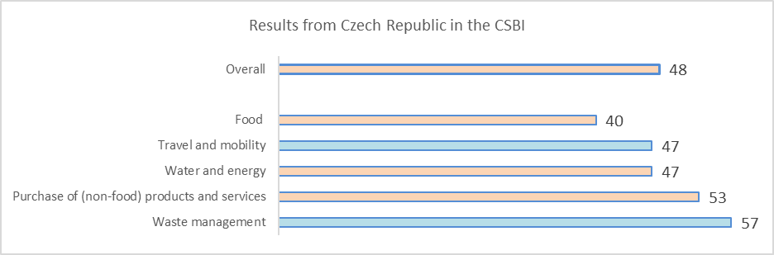
Above the average
On the average
Below the average

Czech Republic scores below the average overall and on the average on “travel and mobility” and “waste management”. The most important variable for explaining the differences is age. Female respondents older than 55 score the highest in the CSBI (51). Male respondents 55 years old and younger score the lowest in the CSBI (46).

Below some relevant data on the behavior of Czechs by dimension:

- Less than 1% of respondents describe themselves as vegan and 1% as vegetarian, whereas 57% eat animal products without trying to reduce its consumption

- 24% follow the behavior of trying to reduce food waste “almost completely”. On the contrary, 9% do not follow this behavior “at all” or “only little”

- 21% of respondents follow the behavior “mainly walking, use the bicycle and/or public transport in daily mobility “(almost) completely”

- 42% try to avoid flying “a lot” or “almost completely”
- 17% consider that they have, almost completely, a well insulated home

- In relation to having energy saving habits in the household, 2% follow this behavior “not at all” and 7% “little”
- 13% reduces/avoids overconsumption “almost completely”, whereas 12% “not at all” or “little”

- 52% prefers products that are of better quality, long lasting, and that can be repaired (“almost completely”+ “a lot”)

- 30% follows the behavior reusing products as long as possible “almost completely”

- For repairing products as much as possible instead of buying new ones, 16% do it “not at all” or “little”, whereas 10% “almost completely”

Importance attributed to dimensions and behaviors: comparisons
The following graph shows the importance (position) attributed to the dimensions included in the research in relation to their impact on sustainability: by Czech respondents and in the survey overall and by experts in the DELPHI research:

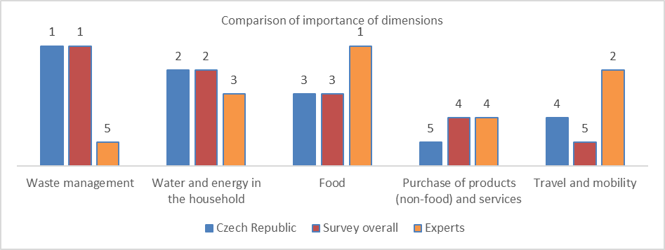

Czech respondents consider “waste management” as the most important dimension, followed by “water and energy in the household”, “food”, “travel and mobility” and “purchase of products…”. Differences between Czech respondents and survey overall are minor: only one position more for “travel and mobility” and one less for “purchase of products…”.
However, Czech respondents differ significantly from expert’s opinion. Most important differences:

- “Waste management” is the most important dimension for Czechs and the least important for experts

- “Travel and mobility” takes the 4th position in importance for Czechs and the second for experts. Czechs consider that “not having a car” is the least important behavior for the dimension, whereas for experts is the third; only 19% of Czechs consider this behavior of “(very) high importance” for sustainability

- “Food” takes the third position in importance for Czechs, whereas for experts is the most important dimension in relation to its impact on sustainability. Czechs consider that the behavior “following a plant-based diet” is the least important, whereas for experts is the most important; 45% of Czechs consider it of “(very) low importance” for sustainability.
Perceived level of information, sustainability of the own behavior and importance attributed to having a sustainable behavior

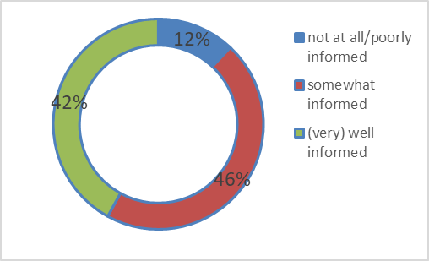
- Highest percentage of (very) well informed for “waste management”: 65%

- Lowest percentage of (very) well informed for “purchase of products…”: 41%

- Those who feel overall (very) well informed score higher (52) in the CSBI than those who feel not at all/poorly informed (42)

Overall perceived information about sustainability

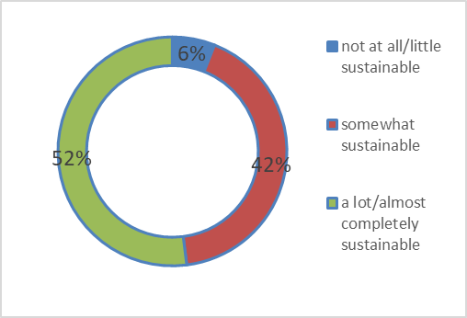
Perceived sustainability of the own behavior
- For “waste management”, the percentage of those with a behavior a lot/almost completely sustainable is the highest: 65%

- For “purchase of (non) food products and services”, the lowest: 42%

- Those who perceive themselves as behaving more sustainably score higher (53) in the CSBI than those with a lower perception of sustainability in the own behavior (35)

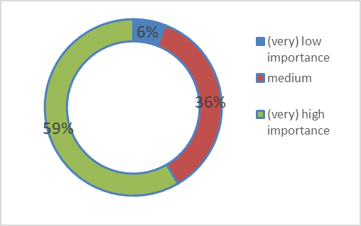
- Highest percentage of (very) high importance for “waste management”: 70%

- Lowest percentage of (very) high importance for “purchase of products…”: 45%

- Those who attribute a (very) high importance score higher (52) in the CSBI than those who attribute a (very) low importance (33)

Importance attributed to a personal sustainable behavior

Most important barriers to have a (more) sustainable behavior by dimension
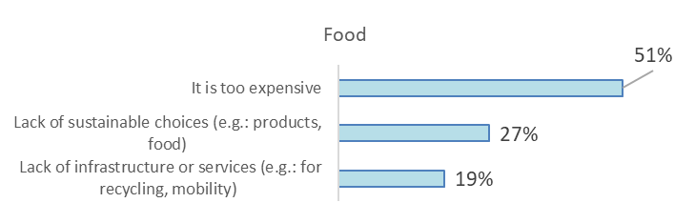

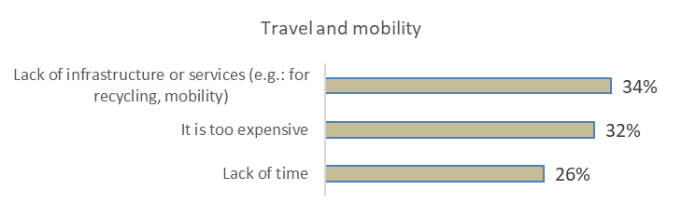
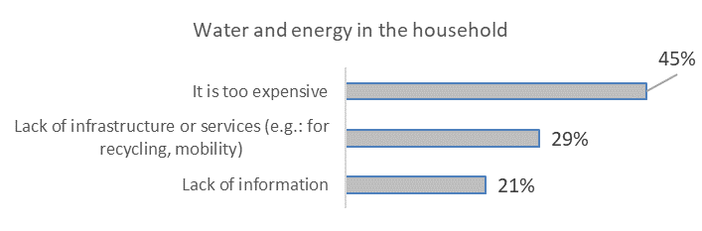

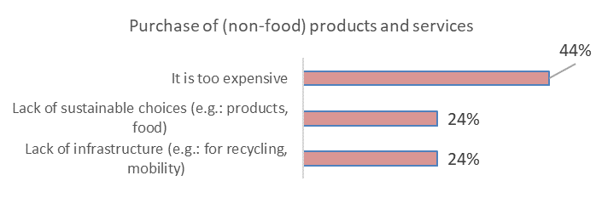
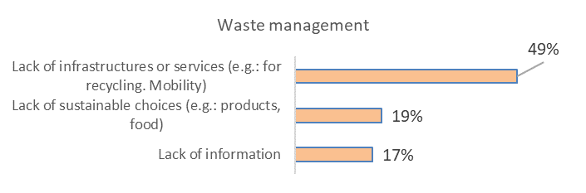

Denmark
CSBI results
Denmark obtains the following scores in the CSBI
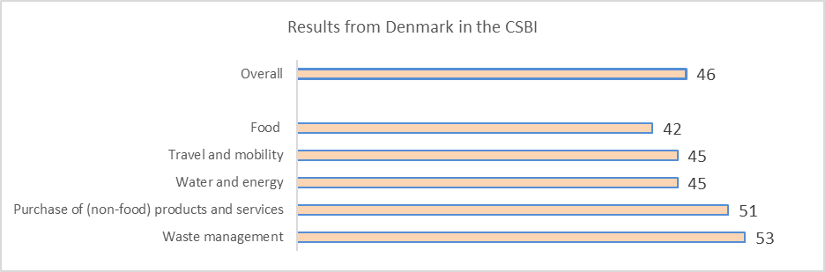
Above the average
On the average
Below the average

Denmark scores below the average overall and in the rest of the dimensions. The most important variable for explaining the differences is age. Female respondents above 61 years old score the highest in the CSBI (60). Respondents 26 years old or younger score the lowest in the CSBI (51,0).

Below some relevant data on the behavior of Danish by dimension:

- 1% of respondents describe themselves as vegan and 3% as vegetarian, whereas 51% eat animal products without trying to reduce its consumption

- 24% follow the behavior of trying to reduce food waste “almost completely”. On the contrary, 12% do not follow this behavior “at all” or “only little”

- 20% of respondents follow the behavior “mainly walking, use the bicycle and/or public transport in daily mobility “(almost) completely”

- 32% try to avoid flying “a lot” or “almost completely”
- 11% consider that they have, almost completely, a well insulated home

- In relation to having energy saving habits in the household, 7% follow this behavior “not at all” and 13% “little”
- 14% reduces/avoids overconsumption “almost completely”, whereas 21% “not at all” or “little”

- 42% prefers products that are of better quality, long lasting, and that can be repaired (“almost completely”+ “a lot”)

- 18% follows the behavior reusing products as long as possible “almost completely”

- For repairing products as much as possible instead of buying new ones, 28% do it “not at all” or “little”, whereas 13% “almost completely”

Importance attributed to dimensions and behaviors: comparisons
The following graph shows the importance (position) attributed to the dimensions included in the research in relation to their impact on sustainability: by Danish respondents and in the survey overall and by experts in the DELPHI research:

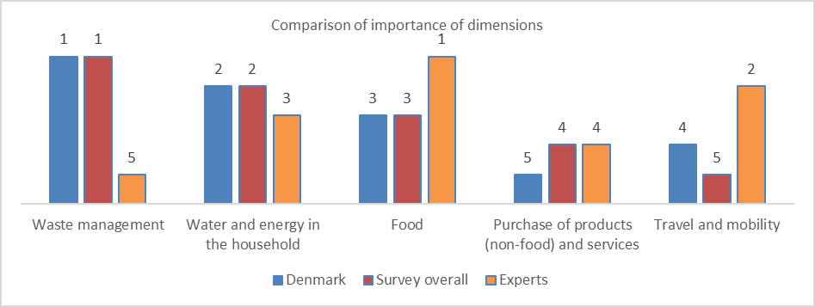

Danish respondents consider “waste management” as the most important dimension, followed by “water and energy in the household”, “food”, “travel and mobility” and “purchase of products…”. Differences between Danish respondents and survey overall are minor: only one position more for “travel and mobility” and one less for “purchase of products…”.
However, Danish respondents differ significantly from expert’s opinion. Most important differences:

- “Waste management” is the most important dimension for Danish and the least important for experts

- “Travel and mobility” takes the 4th position in importance for Danish and the second for experts. Danish consider that “not having a car” is the least important behavior for the dimension, whereas for experts is the third; only 28% of Danish consider this behavior of “(very) high importance” for sustainability

- “Food” takes the third position in importance for Danish, whereas for experts is the most important dimension in relation to its impact on sustainability. Danish consider that the behavior “following a plant-based diet” is the least important, whereas for experts is the most important; 49% of Danish consider it of “(very) low importance” for sustainability.
Perceived level of information, sustainability of the own behavior and importance attributed to having a sustainable behavior

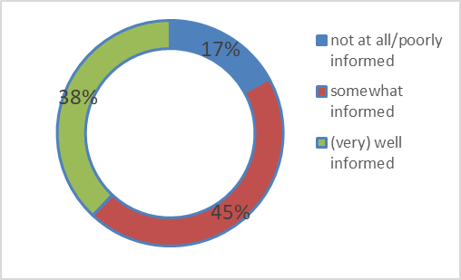
- Highest percentage of (very) well informed for “waste management”: 57%

- Lowest percentage of (very) well informed for “purchase of products…”: 34%

- Those who feel overall (very) well informed score higher (54) in the CSBI than those who feel not at all/poorly informed (37)

Overall perceived information about sustainability

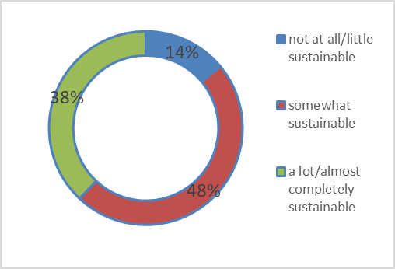
- For “waste management”, the percentage of those with a behavior a lot/almost completely sustainable is the highest: 59%

- For “purchase of (non) food products and services”, the lowest: 32%

- Those who perceive themselves as behaving more sustainably score higher (56) in the CSBI than those with a lower perception of sustainability in the own behavior (33)

Perceived sustainability of the own behavior

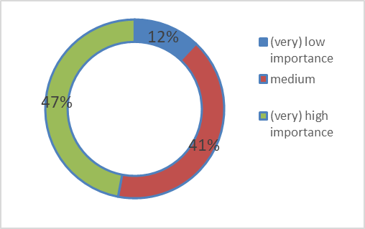
- Highest percentage of (very) high importance for “waste management”: 62%

- Lowest percentage of (very) high importance for “travel and mobility”: 36%

- Those who attribute a (very) high importance score higher (55) in the CSBI than those who attribute a (very) low importance (32)

Importance attributed to a personal sustainable behavior

Most important barriers to have a (more) sustainable behavior by dimension

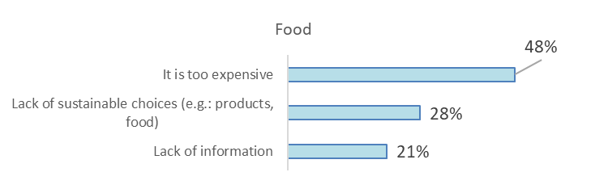

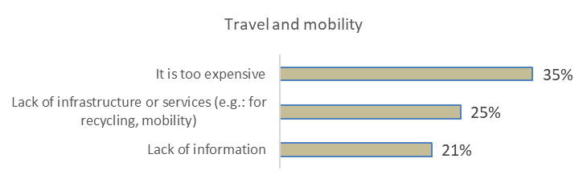

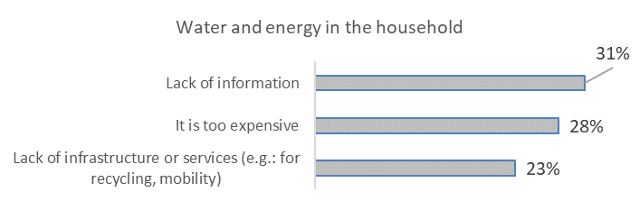

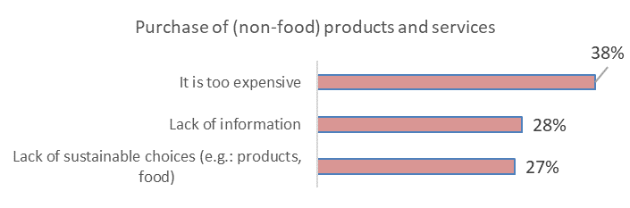

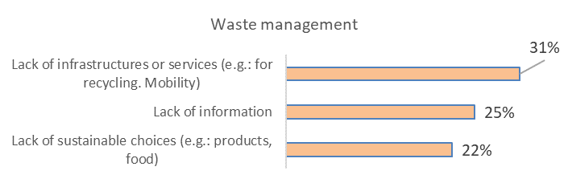

France
CSBI results
France obtains the following scores in the CSBI
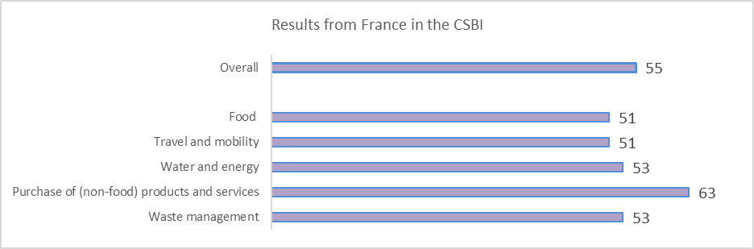
Above the average
On the average
Below the average

France scores above the average overall and in the rest of the dimensions. The most important variable for explaining the differences is age. Female respondents above 61 years old score the highest in the CSBI (60,4). Respondents 26 years old or younger score the lowest in the CSBI (51,0).

Below some relevant data on the behavior of French by dimension:

- Less than 1% of respondents describe themselves as vegan and 3% as vegetarian, whereas 41% eat animal products without trying to reduce its consumption

- 45% follow the behavior of trying to reduce food waste “almost completely”. On the contrary, 4% do not follow this behavior “at all” or “only little”

- 19% of respondents follow the behavior “mainly walking, use the bicycle and/or public transport in daily mobility “(almost) completely”

- 54% try to avoid flying “a lot” or “almost completely”
- 27% consider that they have, almost completely, a well insulated home

- In relation to having energy saving habits in the household, 3% follow this behavior “not at all” and 5% “little”
- 24% reduces/avoids overconsumption “almost completely”, whereas 9% “not at all” or “little”

- 63% prefers products that are of better quality, long lasting, and that can be repaired (“almost completely”+ “a lot”)

- 43% follows the behavior reusing products as long as possible “almost completely”

- For repairing products as much as possible instead of buying new ones, 14% do it “not at all” or “little”, whereas 24% “almost completely”

Importance attributed to dimensions and behaviors: comparisons
The following graph shows the importance (position) attributed to the dimensions included in the research in relation to their impact on sustainability: by French respondents and in the survey overall and by experts in the DELPHI research:

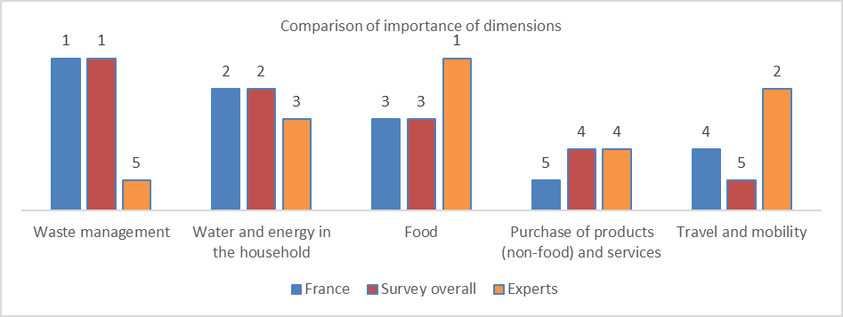

French respondents consider “waste management” as the most important dimension, followed by “water and energy in the household”, “food”, “travel and mobility” and “purchase of products…”. Differences between French respondents and survey overall are minor: only one position more for “travel and mobility” and one less for “purchase of products…”.
However, French respondents differ significantly from expert’s opinion. Most important differences:

- “Waste management” is the most important dimension for French and the least important for experts
- “Travel and mobility” takes the 4th position in importance for French and the second for experts. French consider that “not having a car” is the least important behavior for the dimension, whereas for experts is the third; only 20% of French consider this behavior of “(very) high importance” for sustainability

- “Food” takes the third position in importance for French, whereas for experts is the most important dimension in relation to its impact on sustainability. French consider that the behavior “following a plant-based diet” is the least important, whereas for experts is the most important; 33% of French consider it of “(very) low importance” for sustainability.
Perceived level of information, sustainability of the own behavior and importance attributed to having a sustainable behavior

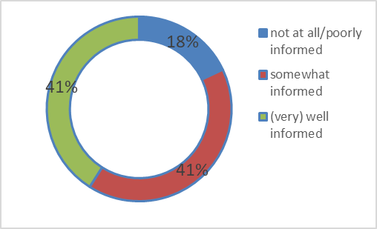
Overall perceived information about sustainability
- Highest percentage of (very) well informed for “waste management”: 60%

- Lowest percentage of (very) well informed for “purchase of products…”: 41%

- Those who feel overall (very) well informed score higher (60) in the CSBI than those who feel not at all/poorly informed (47)

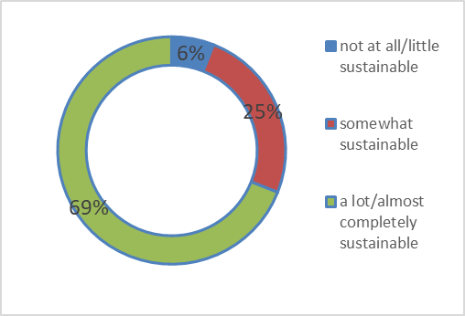
Perceived sustainability of the own behavior
- For “waste management”, the percentage of those with a behavior a lot/almost completely sustainable is the highest: 74%

- For “travel and mobility”, the lowest: 53%

- Those who perceive themselves as behaving more sustainably score higher (59) in the CSBI than those with a lower perception of sustainability in the own behavior (39)

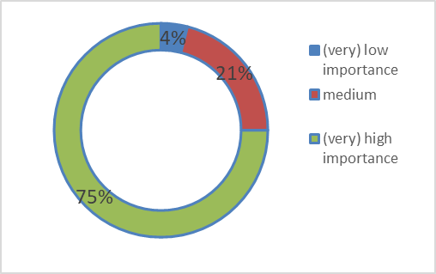
- Highest percentage of (very) high importance for “waste management”: 79%

- Lowest percentage of (very) high importance for “travel and mobility”: 61%

- Those who attribute a (very) high importance score higher (58) in the CSBI than those who attribute a (very) low importance (40)

Importance attributed to a personal sustainable behavior

Most important barriers to have a (more) sustainable behavior by dimension
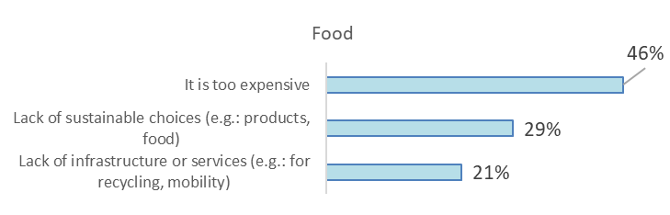

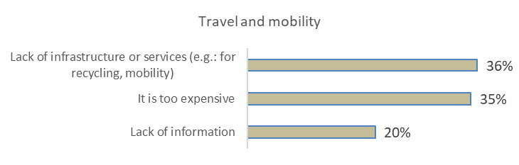

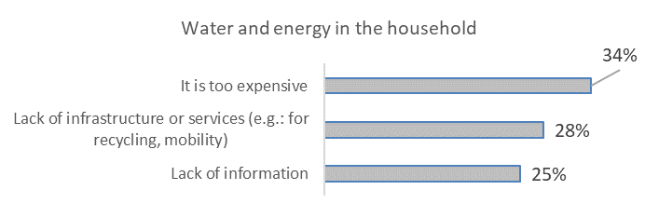

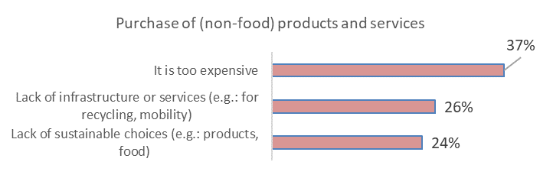

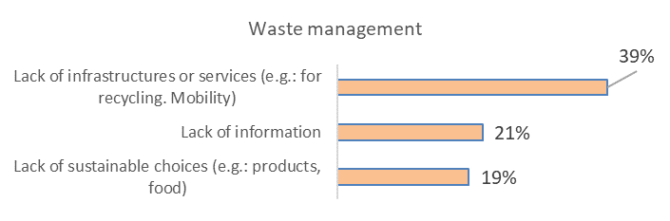

Germany
CSBI results
Germany obtains the following scores in the CSBI
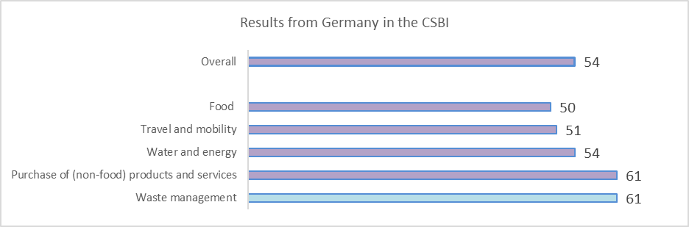
Above the average
On the average
Below the average

Germany scores above the average overall and in almost all dimensions. The most important variable for explaining the differences is age. Respondents above 59 score the highest in the CSBI (58).
Male respondents, 59 years old or younger, and with very difficult/difficult/sufficient to make ends meet financial situation score the lowest in the CSBI (50).

Below some relevant data on the behavior of French by dimension:

- Less than 1% of respondents describe themselves as vegan and 4% as vegetarian, whereas 33% eat animal products without trying to reduce its consumption

- 25% follow the behavior of trying to reduce food waste “almost completely”. On the contrary, 8% do not follow this behavior “at all” or “only little”

- 21% of respondents follow the behavior “mainly walking, use the bicycle and/or public transport in daily mobility “(almost) completely”

- 55% try to avoid flying “a lot” or “almost completely”
- 16% consider that they have, almost completely, a well insulated home

- In relation to having energy saving habits in the household, 3% follow this behavior “not at all” and 8% “little”
- 14% reduces/avoids overconsumption “almost completely”, whereas 11% “not at all” or “little”

- 65% prefers products that are of better quality, long lasting, and that can be repaired (“almost completely”+ “a lot”)

- 30% follows the behavior reusing products as long as possible “almost completely”

- For repairing products as much as possible instead of buying new ones, 19% do it “not at all” or “little”, whereas 16% “almost completely”

Importance attributed to dimensions and behaviors: comparisons
The following graph shows the importance (position) attributed to the dimensions included in the research in relation to their impact on sustainability: by German respondents and in the survey overall and by experts in the DELPHI research:
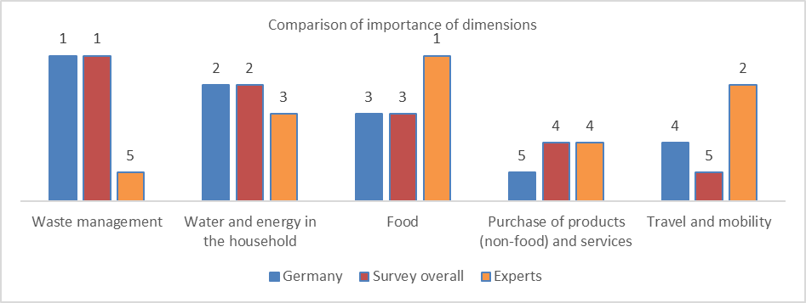

German respondents consider “waste management” as the most important dimension, followed by “water and energy in the household”, “food”, “travel and mobility” and “purchase of products…”. Differences between German respondents and survey overall are minor: only one position more for “travel and mobility” and one less for “purchase of products…”.
However, German respondents differ significantly from expert’s opinion. Most important differences:

- “Waste management” is the most important dimension for Germans and the least important for experts

- “Travel and mobility” takes the 4th position in importance for Germans and the second for experts. French consider that “not having a car” is the least important behavior for the dimension, whereas for experts is the third; only 26% of Germans consider this behavior of “(very) high importance” for sustainability

- “Food” takes the third position in importance for Germans, whereas for experts is the most important dimension in relation to its impact on sustainability. Germans consider that the behavior “following a plant-based diet” is the least important, whereas for experts is the most important; 37% of Germans consider it of “(very) low importance” for sustainability.

Perceived level of information, sustainability of the own behavior and importance attributed to having a sustainable behavior

- Highest percentage of (very) well informed for “waste management”: 65%

- Lowest percentage of (very) well informed for “purchase of products…”: 50%

- Those who feel overall (very) well informed score higher (60) in the CSBI than those who feel not at all/poorly informed (42)

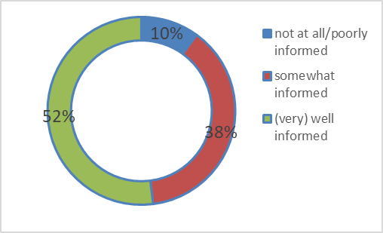
Overall perceived information about sustainability

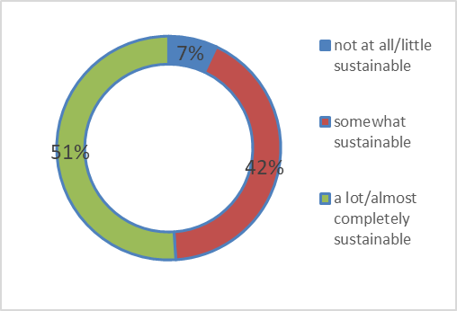
- For “waste management”, the percentage of those with a behavior a lot/almost completely sustainable is the highest: 68%

- For “purchase of products...”, the lowest: 43%

- Those who perceive themselves as behaving more sustainably score higher (61) in the CSBI than those with a lower perception of sustainability in the own behavior (37)

Perceived sustainability of the own behavior

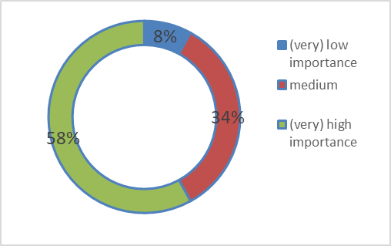
- Highest percentage of (very) high importance for “waste management”: 71%

- Lowest percentage of (very) high importance for “travel and mobility”: 50%

- Those who attribute a (very) high importance score higher (60) in the CSBI than those who attribute a (very) low importance (39)

Importance attributed to a personal sustainable behavior

Most important barriers to have a (more) sustainable behavior by dimension

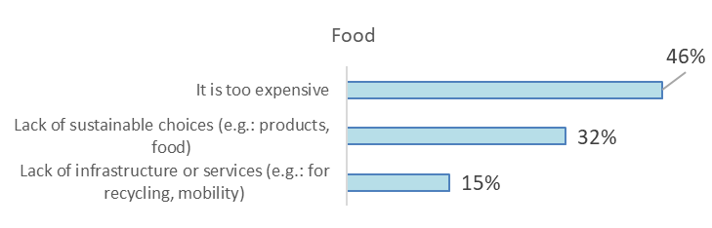

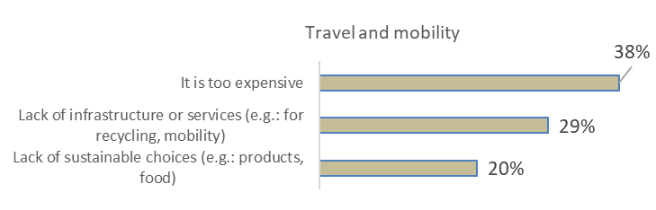

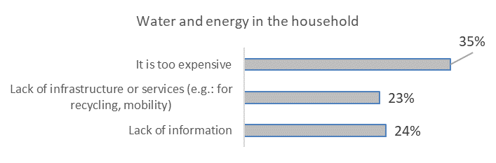

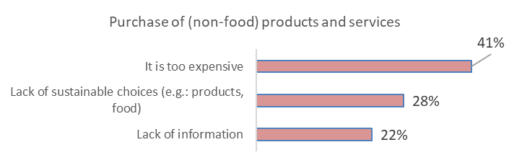

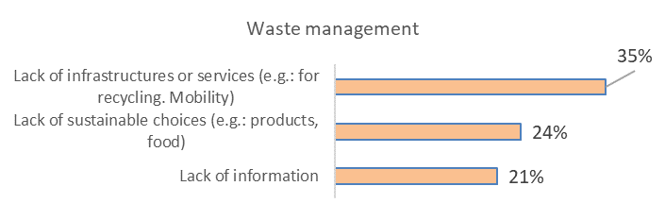

Italy
CSBI results
Italy obtains the following scores in the CSBI
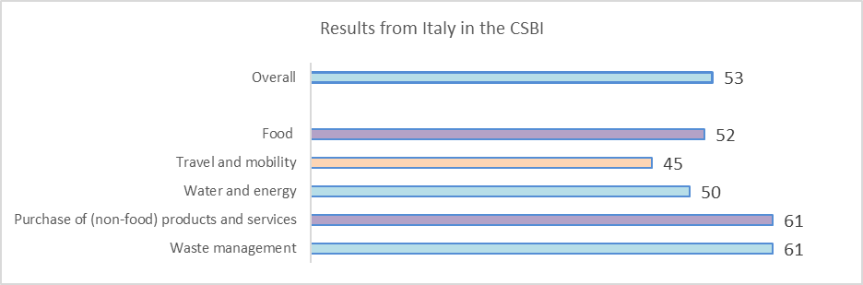
Above the average
On the average
Below the average

Italy scores on the average overall and above the average in food and purchase of (non-food) products and services. The most important variable for explaining the differences is educational level. Female respondents with a medium educational level and above 55 years old score the highest in the CSBI (58).
Male respondents with a low educational level score the lowest in the CSBI (49).

Below some relevant data on the behavior of Italians by dimension:

- Less than 1% of respondents describe themselves as vegan and 3% as vegetarian, whereas 26% eat animal products without trying to reduce its consumption

- 37% follow the behavior of trying to reduce food waste “almost completely”. On the contrary, 4% do not follow this behavior “at all” or “only little”

- 15% of respondents follow the behavior “mainly walking, use the bicycle and/or public transport in daily mobility “(almost) completely”

- 43% try to avoid flying “a lot” or “almost completely”
- 12% consider that they have, almost completely, a well insulated home

- In relation to having energy saving habits in the household, 1% follow this behavior “not at all” and 3% “little”
- 20% reduces/avoids overconsumption “almost completely”, whereas 10% “not at all” or “little”

- 57% prefers products that are of better quality, long lasting, and that can be repaired (“almost completely”+ “a lot”)

- 23% follows the behavior reusing products as long as possible “almost completely”

- For repairing products as much as possible instead of buying new ones, 11% do it “not at all” or “little”, whereas 21% “almost completely”

Importance attributed to dimensions and behaviors: comparisons
The following graph shows the importance (position) attributed to the dimensions included in the research in relation to their impact on sustainability: by Italian respondents and in the survey overall and by experts in the DELPHI research:
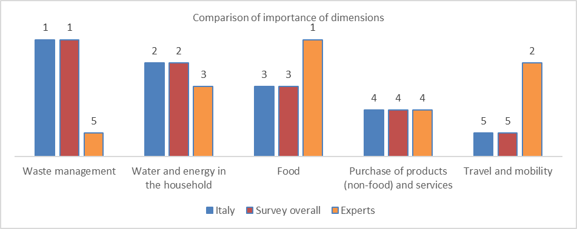

Italian respondents consider “waste management” as the most important dimension, followed by “water and energy in the household”, “food”, “purchase of products…” and “travel and mobility”.There are no differences whatsoever between Italian respondents and the survey overall.
However, Italian respondents differ significantly from expert’s opinion. Most important differences:

- “Waste management” is the most important dimension for Italians and the least important for experts
- “Travel and mobility” is the least important for Italians and the second for experts. Italians consider that “not having a car” is the least important behavior for the dimension, whereas for experts is the third; only 21% of Italians consider this behavior of “(very) high importance” for sustainability
- “Food” takes the third position in importance for Italians, whereas for experts is the most important dimension in relation to its impact on sustainability. Italians consider that the behavior “following a plant-based diet” is the least important, whereas for experts is the most important; 31% of Italians consider it of “(very) low importance” for sustainability.

Perceived level of information, sustainability of the own behavior and importance attributed to having a sustainable behavior

- Highest percentage of (very) well informed for “waste management”: 64%

- Lowest percentage of (very) well informed for “purchase of products…”: 50%

- Those who feel overall (very) well informed score higher (59) in the CSBI than those who feel not at all/poorly informed (40)

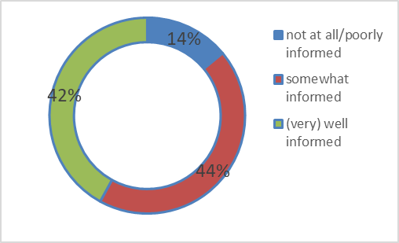
Overall perceived information about sustainability

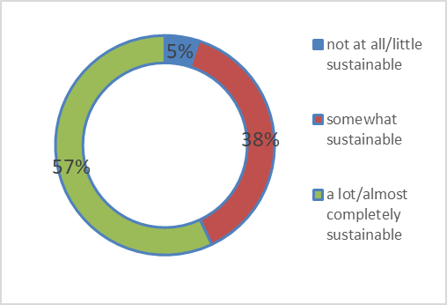
- For “waste management”, the percentage of those with a behavior a lot/almost completely sustainable is the highest: 71%

- For “travel and mobility”, the lowest: 40%

- Those who perceive themselves as behaving more sustainably score higher (59) in the CSBI than those whit a lower perception of sustainability in the own behavior (34)

Perceived sustainability of the own behavior

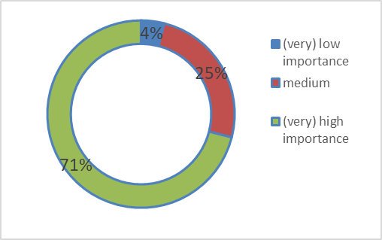
- Highest percentage of (very) high importance for “waste management”: 79%

- Lowest percentage of (very) high importance for “travel and mobility”: 50%

- Those who attribute a (very) high importance score higher (57) in the CSBI than those who attribute a (very) low importance (34)

Importance attributed to a personal sustainable behavior

Most important barriers to have a (more) sustainable behavior by dimension
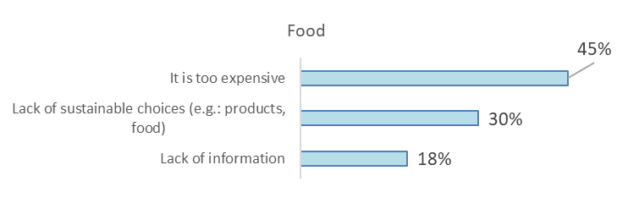
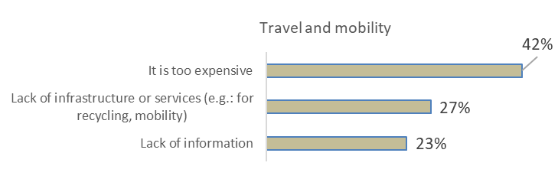

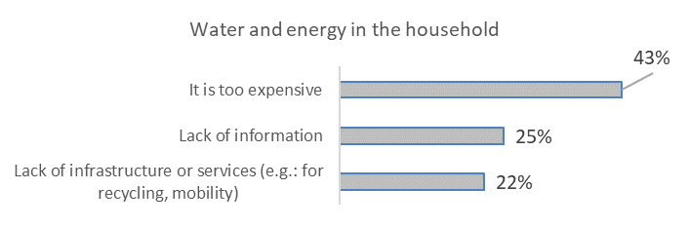

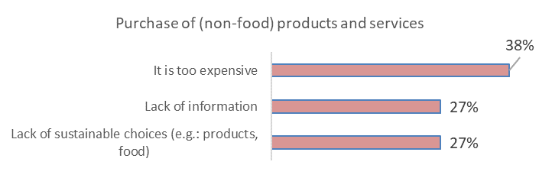

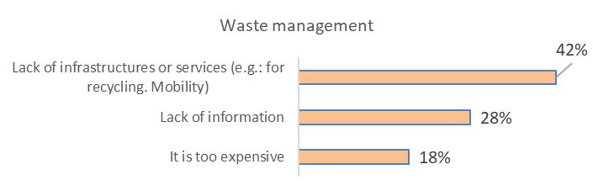

Portugal
CSBI results
Portugal obtains the following scores in the CSBI
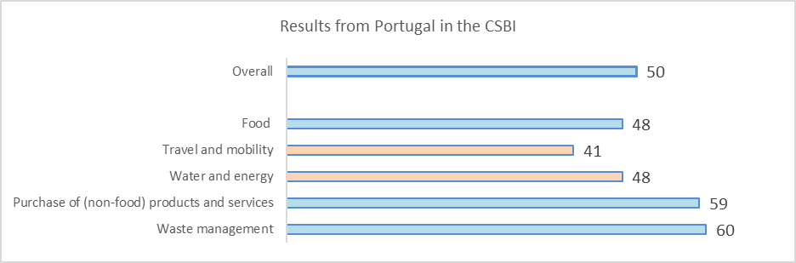
Above the average
On the average
Below the average

Portugal scores on the average overall and above the average in travel and mobility and water and energy. The most important variable for explaining the differences is gender. Male respondents with a very comfortable/comfortable financial situation score the highest in the CSBI (55). Male respondents with a very difficult/difficult/sufficient to make ends meet financial situation and 38 years old or younger score the lowest in the CSBI (44).

Below some relevant data on the behavior of Portuguese by dimension:

- Less than 1% of respondents describe themselves as vegan and 2% as vegetarian, whereas 27% eat animal products without trying to reduce its consumption

- 25% follow the behavior of trying to reduce food waste “almost completely”. On the contrary, 9% do not follow this behavior “at all” or “only little”

- 15% of respondents follow the behavior “mainly walking, use the bicycle and/or public transport in daily mobility “(almost) completely”

- 33% try to avoid flying “a lot” or “almost completely”
- 11% consider that they have, almost completely, a well insulated home

- In relation to having energy saving habits in the household, 2% follow this behavior “not at all” and 7% “little”
- 21% reduces/avoids overconsumption “almost completely”, whereas 11% “not at all” or “little”

- 61% prefers products that are of better quality, long lasting, and that can be repaired (“almost completely”+ “a lot”)

- 26% follows the behavior reusing products as long as possible “almost completely”

- For repairing products as much as possible instead of buying new ones, 15% do it “not at all” or “little”, whereas 21% “almost completely”

Importance attributed to dimensions and behaviors: comparisons
The following graph shows the importance (position) attributed to the dimensions included in the research in relation to their impact on sustainability: by Portuguese respondents and in the survey overall and by experts in the DELPHI research:
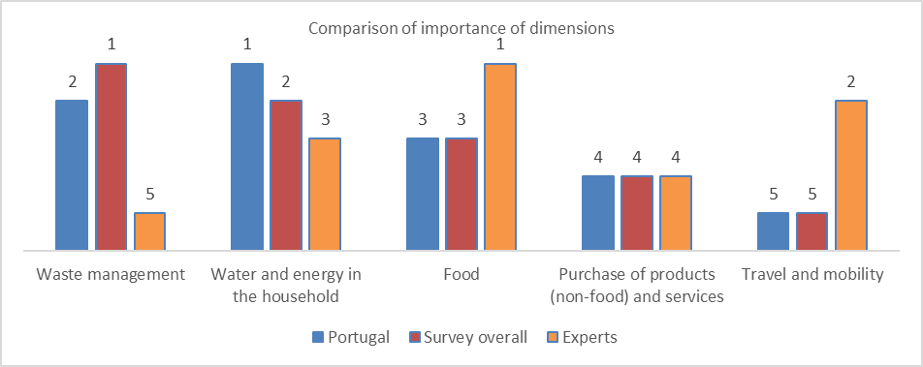

Portuguese respondents consider “water and energy in the household” as the most important dimension, followed by “waste management”, “food”, “purchase of products…” and “travel and mobility”. Differences with the survey overall are minor (in “waste management” and “water and energy”, for just one position.
However, Portuguese respondents differ significantly from expert’s opinion. Most important differences:

- “Waste management” is the second most important dimension for Portuguese and the least important for experts
- “Travel and mobility” is the least important for Portuguese and the second for experts. Portuguese consider that “not having a car” is the least important behavior for the dimension, whereas for experts is the third; only 22% of Portuguese consider this behavior of “(very) high importance” for sustainability
- “Food” takes the third position in importance for Portuguese, whereas for experts is the most important dimension in relation to its impact on sustainability. Portuguese consider that the behavior “following a plant-based diet” is the least important, whereas for experts is the most important; 26% of Portuguese consider it of “(very) low importance” for sustainability

Perceived level of information, sustainability of the own behavior and importance attributed to having a sustainable behavior

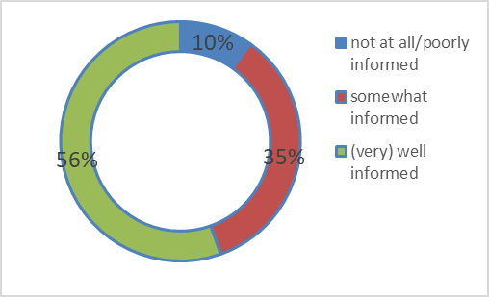
Overall perceived information about sustainability
- Highest percentage of (very) well informed for “waste management”: 66%

- Lowest percentage of (very) well informed for “purchase of products…”: 46%

- Those who feel overall (very) well informed score higher (54) in the CSBI than those who feel not at all/poorly informed (40)

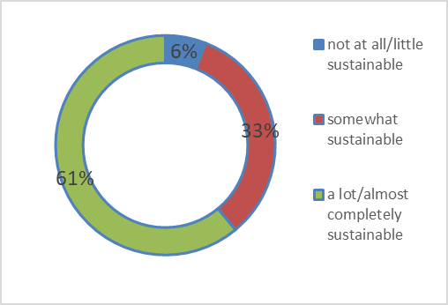
- For “waste management”, the percentage of those with a behavior a lot/almost completely sustainable is the highest: 61%

- For “travel and mobility”, the lowest: 38%

- Those who perceive themselves as behaving more sustainably score higher (55) in the CSBI than those with a lower perception of sustainability in the own behavior (36)

Perceived sustainability of the own behavior

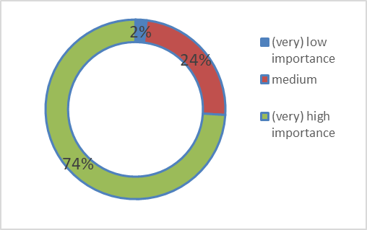
Importance attributed to a personal sustainable behavior
- Highest percentage of (very) high importance for “water and energy…”: 76%

- Lowest percentage of (very) high importance for “travel and mobility”: 54%

- Those who attribute a (very) high importance score higher (53) in the CSBI than those who attribute a (very) low importance (26)

Most important barriers to have a (more) sustainable behavior by dimension
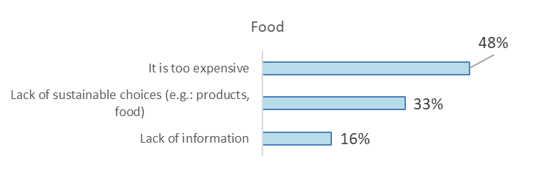

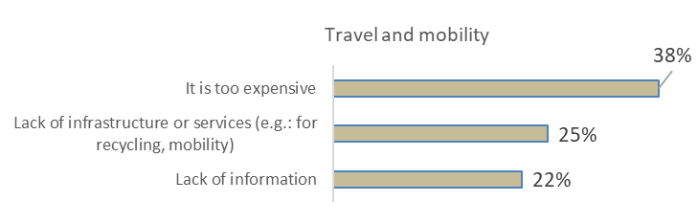
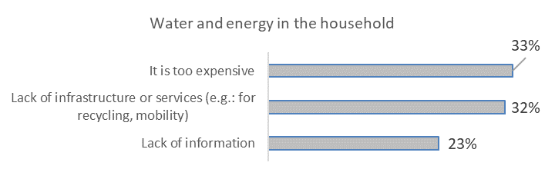
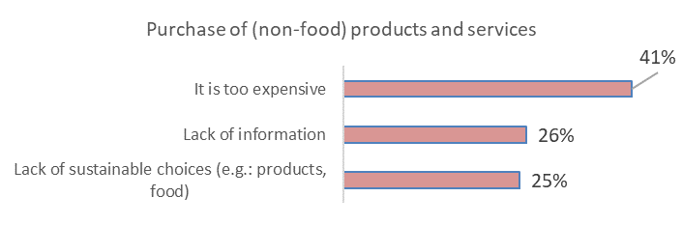
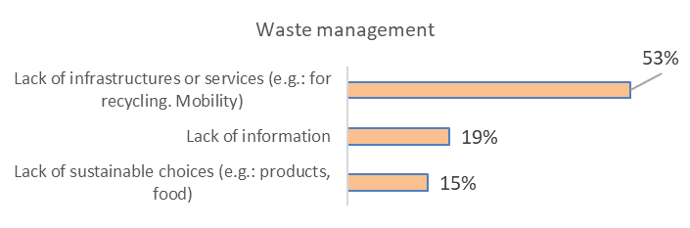

Russia
CSBI results
Russia obtains the following scores in the CSBI
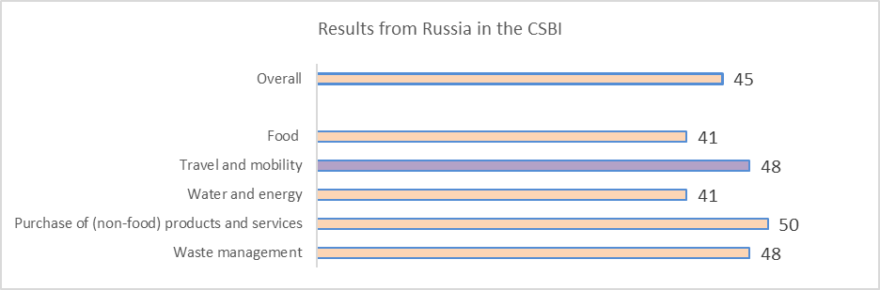
Above the average
On the average
Below the average

Russia scores below the average overall and in all dimensions apart from travel and mobility. The most important variable for explaining the differences is gender. Female respondents older than 53 years old score the highest in the CSBI (49). Male respondents score the lowest in the CSBI (44).

Below some relevant data on the behavior of Russians by dimension:

- Less than 1% of respondents describe themselves as vegan and/or 2% vegetarian, whereas 64% eat animal products without trying to reduce its consumption

- 18% follow the behavior of trying to reduce food waste “almost completely”. On the contrary, 18% do not follow this behavior “at all” or “only little”

- 20% of respondents follow the behavior “mainly walking, use the bicycle and/or public transport in daily mobility “(almost) completely”

- 23% try to avoid flying “a lot” or “almost completely”
- 12% consider that they have, almost completely, a well insulated home

- In relation to having energy saving habits in the household, 7% follow this behavior “not at all” and 11% “little”
- 8% reduces/avoids overconsumption “almost completely”, whereas 22% “not at all” or “little”

- 59% prefers products that are of better quality, long lasting, and that can be repaired (“almost completely”+ “a lot”)

- 10% follows the behavior reusing products as long as possible “almost completely”

- For repairing products as much as possible instead of buying new ones, 13% do it “not at all” or “little”, whereas 11% “almost completely”

Importance attributed to dimensions and behaviors: comparisons
The following graph shows the importance (position) attributed to the dimensions included in the research in relation to their impact on sustainability: by Russian respondents and in the survey overall and by experts in the DELPHI research:
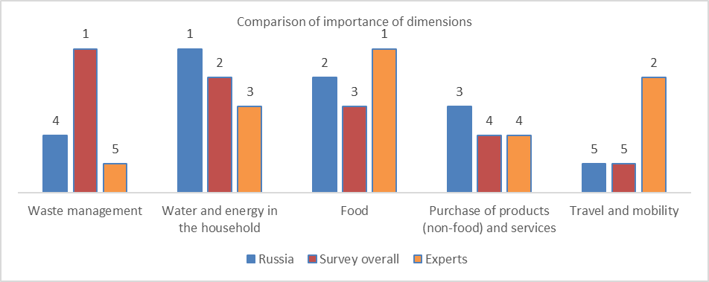

Russian respondents consider “water and energy in the household” as the most important dimension, followed by “food”, “purchase of products…”, “waste management” and “travel and mobility”. The main difference with the survey overall is that Russians respondents give much less importance to “waste management” (3 positions).

Russian respondents differ also from expert’s opinion. Most important differences:

- “Travel and mobility” is the least important for Russians and the second for experts. Russians consider that “not having a car” is the least important behavior for the dimension, whereas for experts is the third; only 18% of Russians consider this behavior of “(very) high importance” for sustainability
- “Water and energy” takes the first position in importance for Russians, whereas for experts is only the third most important dimension in relation to its impact on sustainability.

Perceived level of information, sustainability of the own behavior and importance attributed to having a sustainable behavior

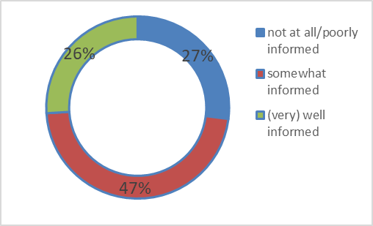
Overall perceived information about sustainability
- Highest percentage of (very) well informed for “waste management”: 56%

- Lowest percentage of (very) well informed for “travel and mobility”: 29%

- Those who feel overall (very) well informed score higher (53) in the CSBI than those who feel not at all/poorly informed (38)

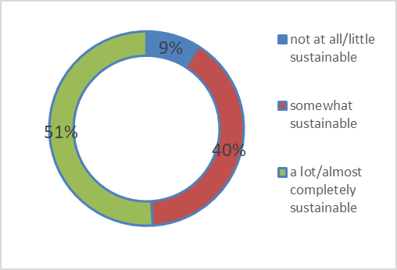
Perceived sustainability of the own behavior
- For “food”, the percentage of those with a behavior a lot/almost completely sustainable is the highest: 62%

- For “travel and mobility”, the lowest: 32%

- Those who perceive themselves as behaving more sustainably score higher (50) in the CSBI than those with a lower perception of sustainability in the own behavior (30)

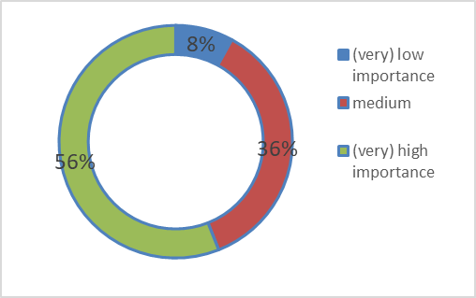
- Highest percentage of (very) high importance for “food”: 68%

- Lowest percentage of (very) high importance for “travel and mobility”: 38%

- Those who attribute a (very) high importance score higher (49) in the CSBI than those who attribute a (very) low importance (30)

Importance attributed to a personal sustainable behavior

Most important barriers to have a (more) sustainable behavior by dimension
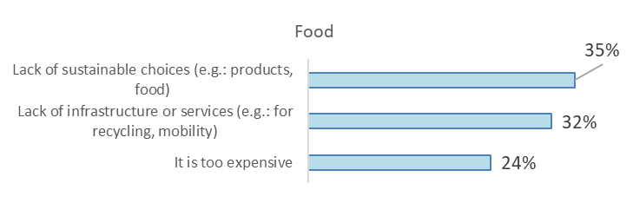
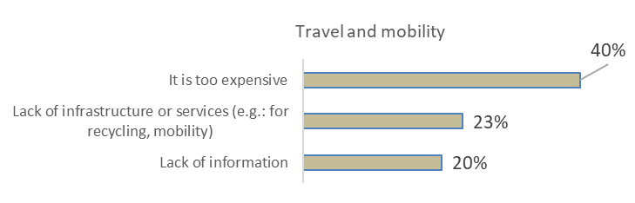
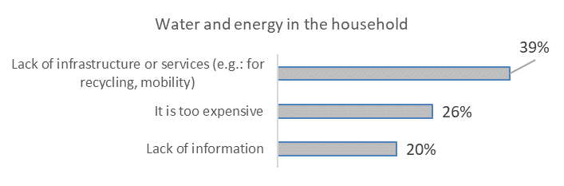
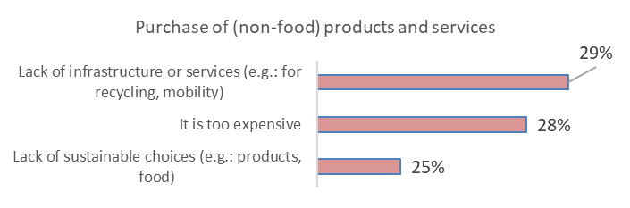
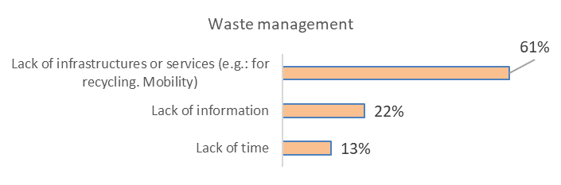

Slovenia
CSBI results
Slovenia obtains the following scores in the CSBI
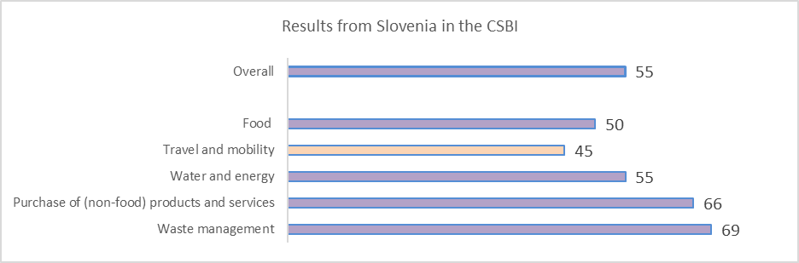
Above the average
On the average
Below the average

Slovenia scores above the average overall and below the average on travel and mobility. The most important variable for explaining the differences is age. Respondents older than 60 years old score the highest in the CSBI (59). Respondents 40 years old or younger score the lowest in the CSBI (54).

Below some relevant data on the behavior of Slovenians by dimension:

- 1% of respondents describe themselves as vegan and 3% as vegetarian, whereas 48% eat animal products without trying to reduce its consumption

- 36% follow the behavior of trying to reduce food waste “almost completely”. On the contrary, 7% do not follow this behavior “at all” or “only little”

- 18% of respondents follow the behavior “mainly walking, use the bicycle and/or public transport in daily mobility “(almost) completely”

- 51% try to avoid flying “a lot” or “almost completely”
- 25% consider that they have, almost completely, a well insulated home

- In relation to having energy saving habits in the household, 1% follow this behavior “not at all” and 7% “little”
- 28% reduces/avoids overconsumption “almost completely”, whereas 7% “not at all” or “little”

- 56% prefers products that are of better quality, long lasting, and that can be repaired (“almost completely”+ “a lot”)

- 42% follows the behavior reusing products as long as possible “almost completely”

- For repairing products as much as possible instead of buying new ones, 6% do it “not at all” or “little”, whereas 36% “almost completely”

Importance attributed to dimensions and behaviors: comparisons
The following graph shows the importance (position) attributed to the dimensions included in the research in relation to their impact on sustainability: by Slovenian respondents and in the survey overall and by experts in the DELPHI research:
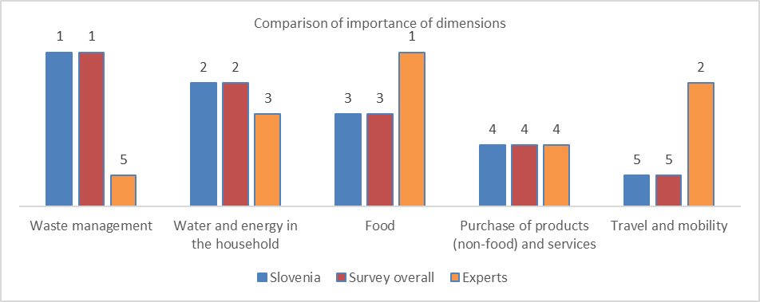
Slovenian respondents consider “waste management” as the most important dimension, followed by “water and energy in the household”, “food”, “purchase of products…” and “travel and mobility”. There are no differences whatsoever between Slovenian respondents and the survey overall.

However, Slovenian respondents differ significantly from expert’s opinion. Most important differences:

- “Waste management” is the most important dimension for Slovenians and the least important for experts

- “Travel and mobility” is the least important for Slovenians and the second for experts. Slovenians consider that “not having a car” is the least important behavior for the dimension, whereas for experts is the third; only 37% of Slovenians consider this behavior of “(very) high importance” for sustainability

- “Food” takes the third position in importance for Slovenians, whereas for experts is the most important dimension in relation to its impact on sustainability. Slovenians consider that the behavior “following a plant-based diet” is the least important, whereas for experts is the most important; 34% of Slovenians consider it of “(very) low importance” for sustainability
Perceived level of information, sustainability of the own behavior and importance attributed to having a sustainable behavior

- Highest percentage of (very) well informed for “waste management”: 86%

- Lowest percentage of (very) well informed for “travel and mobility”: 59%

- Those who feel overall (very) well informed score higher (58) in the CSBI than those who feel not at all/poorly informed (46)

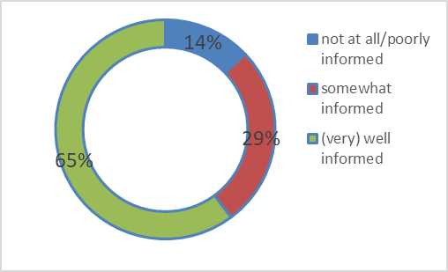
Overall perceived information about sustainability
- For “waste management”, the percentage of those with a behavior a lot/almost completely sustainable is the highest: 82%

- For “travel and mobility”, the lowest: 49%

- Those who perceive themselves as behaving more sustainably score higher (58) in the CSBI than those with a lower perception of sustainability in the own behavior (51)

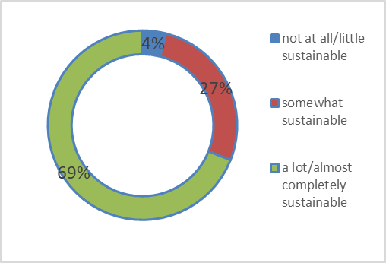
Perceived sustainability of the own behavior

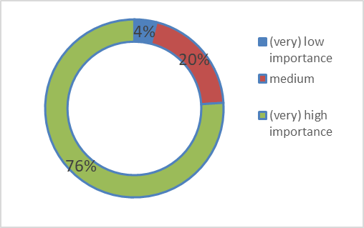
- Highest percentage of (very) high importance for “waste management”: 85%

- Lowest percentage of (very) high importance for “travel and mobility”: 57%

- Those who attribute a (very) high importance score higher (57) in the CSBI than those who attribute a (very) low importance (34)

Importance attributed to a personal sustainable behavior

Most important barriers to have a (more) sustainable behavior by dimension
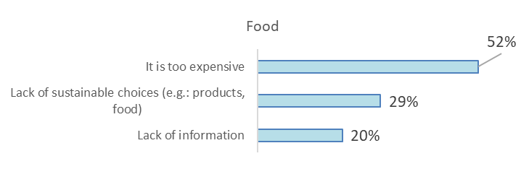

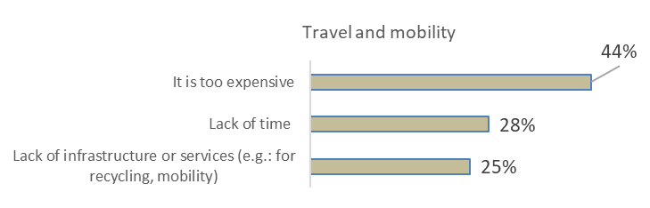

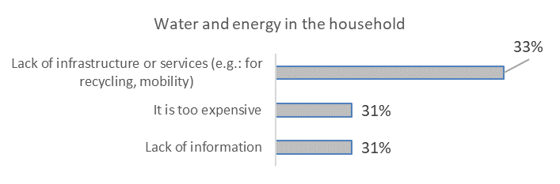

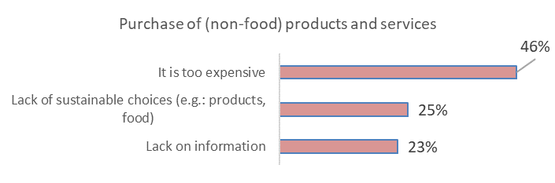
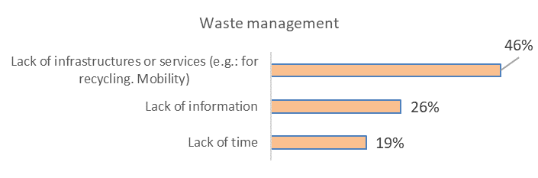

Spain
CSBI results
Spain obtains the following scores in the CSBI
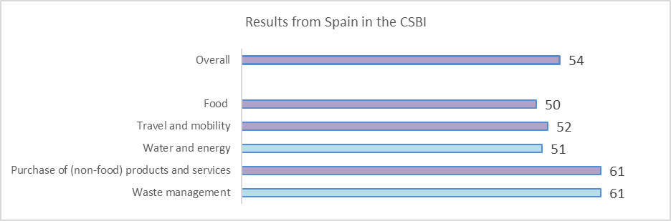
Above the average
On the average
Below the average

Spain scores above the average overall and on the average in water and energy and waste management. No significant results came out of the analysis combining sociodemographics and results in the CSBI.

Below some relevant data on the behavior of Spaniards by dimension:

- 1% of respondents describe themselves as vegan and 1% as vegetarian, whereas 37% eat animal products without trying to reduce its consumption

- 33% follow the behavior of trying to reduce food waste “almost completely”. On the contrary, 6% do not follow this behavior “at all” or “only little”

- 24% of respondents follow the behavior “mainly walking, use the bicycle and/or public transport in daily mobility “(almost) completely”

- 42% try to avoid flying “a lot” or “almost completely”
- 12% consider that they have, almost completely, a well insulated home

- In relation to having energy saving habits in the household, 1% follow this behavior “not at all” and 4% “little”
- 19% reduces/avoids overconsumption “almost completely”, whereas 9% “not at all” or “little”

- 65% prefers products that are of better quality, long lasting, and that can be repaired (“almost completely”+ “a lot”)

- 24% follows the behavior reusing products as long as possible “almost completely”

- For repairing products as much as possible instead of buying new ones, 11% do it “not at all” or “little”, whereas 22% “almost completely”

Importance attributed to dimensions and behaviors: comparisons
The following graph shows the importance (position) attributed to the dimensions included in the research in relation to their impact on sustainability: by Spanish respondents and in the survey overall and by experts in the DELPHI research:
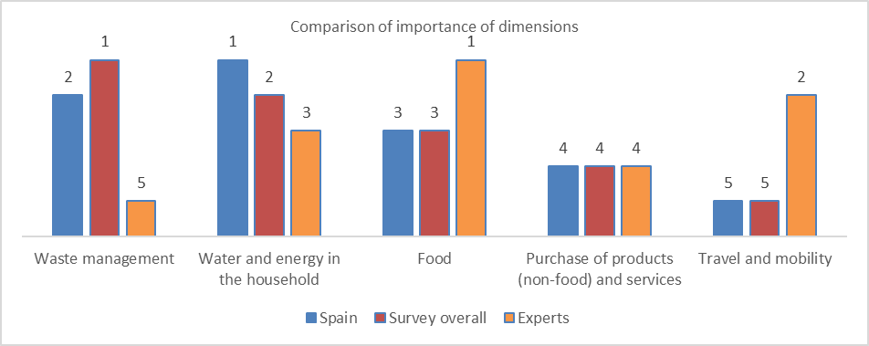

Spanish respondents consider “water and energy in the household” as the most important dimension, followed by “waste management”, “food”, “purchase of products…” and “travel and mobility”. Differences with the survey overall are minor (in “waste management” and “water and energy”, for just one position.
However, Spanish respondents differ significantly from expert’s opinion. Most important differences:

- “Waste management” is the second most important dimension for Spaniards and the least important for experts

- “Travel and mobility” is the least important for Spaniards and the second for experts. Spaniards consider that “not having a car” is the least important behavior for the dimension, whereas for experts is the third; only 28 % of Spaniards consider this behavior of “(very) high importance” for sustainability

- “Food” takes the third position in importance for Spaniards, whereas for experts is the most important dimension in relation to its impact on sustainability. Spaniards consider that the behavior “following a plant-based diet” is the least important, whereas for experts is the most important; 36% of Spaniards consider it of “(very) low importance” for sustainability

Perceived level of information, sustainability of the own behavior and importance attributed to having a sustainable behavior

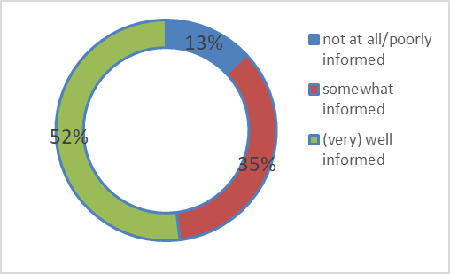
Overall perceived information about sustainability
- Highest percentage of (very) well informed for “food”: 60%

- Lowest percentage of (very) well informed for “purchase of products…”: 49%

- Those who feel overall (very) well informed score higher (59) in the CSBI than those who feel not at all/poorly informed (45)

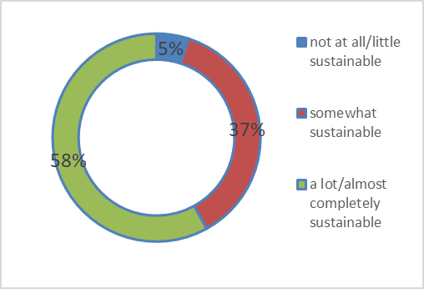
Perceived sustainability of the own behavior
- For “waste management”, the percentage of those with a behavior a lot/almost completely sustainable is the highest: 66%

- For “travel and mobility”, the lowest: 46%

- Those who perceive themselves as behaving more sustainably score higher (58) in the CSBI than those with a lower perception of sustainability in the own behavior (35)

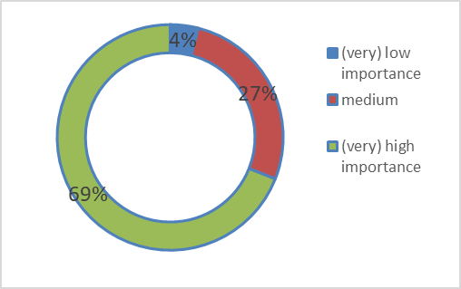
- Highest percentage of (very) high importance for “water and energy…”: 71%

- Lowest percentage of (very) high importance for “travel and mobility”: 56%

- Those who attribute a (very) high importance score higher (58) in the CSBI than those who attribute a (very) low importance (32)

Importance attributed to a personal sustainable behavior

Most important barriers to have a (more) sustainable behavior by dimension
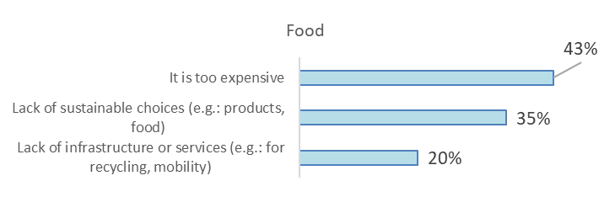

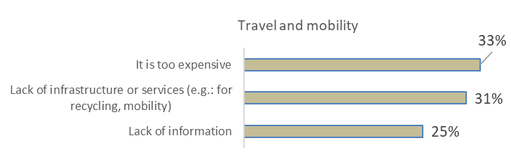

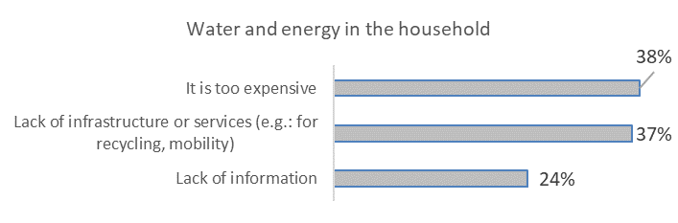

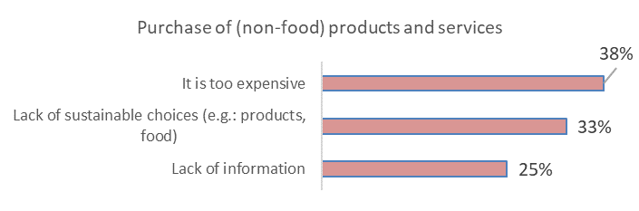
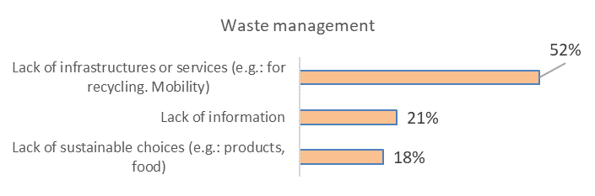

The Netherlands
CSBI results
The Netherlands obtains the following scores in the CSBI
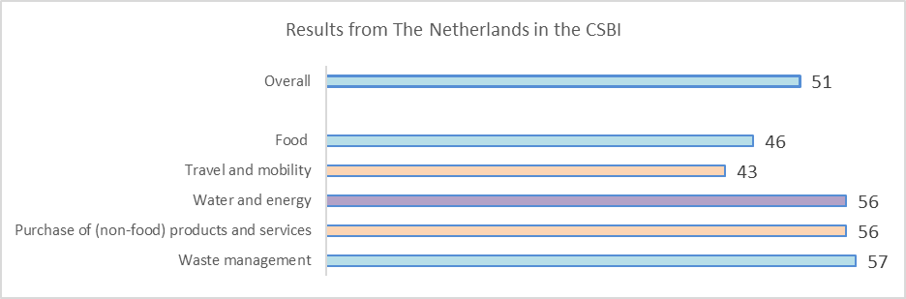
Above the average
On the average
Below the average

The Netherlands scores on the average overall and above the average in water and energy. The most important variable for explaining the differences is age. Respondents older than 64 years old and with a hifg educational level score the highest in the CSBI (59). Respondents 64 years old or younger, male and with a low/medium educational level score the lowest in the CSBI (45)

Below some relevant data on the behavior of Dutch by dimension:

- 2% of respondents describe themselves as vegan and 3% as vegetarian, whereas 36% eat animal products without trying to reduce its consumption

- 30% follow the behavior of trying to reduce food waste “almost completely”. On the contrary, 15% do not follow this behavior “at all” or “only little”

- 23% of respondents follow the behavior “mainly walking, use the bicycle and/or public transport in daily mobility “(almost) completely”

- 27% try to avoid flying “a lot” or “almost completely”
- 21% consider that they have, almost completely, a well insulated home

- In relation to having energy saving habits in the household, 4% follow this behavior “not at all” and 13% “little”
- 23% reduces/avoids overconsumption “almost completely”, whereas 18% “not at all” or “little”

- 56% prefers products that are of better quality, long lasting, and that can be repaired (“almost completely”+ “a lot”)

- 32% follows the behavior reusing products as long as possible “almost completely”

- For repairing products as much as possible instead of buying new ones, 25% do it “not at all” or “little”, whereas 16% “almost completely”

Importance attributed to dimensions and behaviors: comparisons
The following graph shows the importance (position) attributed to the dimensions included in the research in relation to their impact on sustainability: by Dutch respondents and in the survey overall and by experts in the DELPHI research:
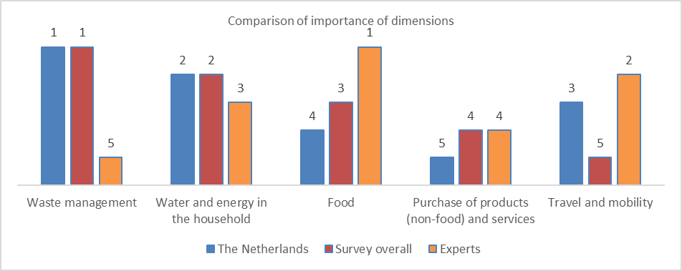

Dutch respondents consider “waste management” as the most important dimension, followed by “water and energy in the household”, “travel and mobility, “food” and “purchase of products…”. Differences with the survey overall are in “food” (1 position), “water and energy” (1 position) and travel and mobility (2 positions)

Dutch respondents differ also from expert’s opinion. Most important differences:

- “Waste management” is the most important dimension for Dutch and the least important for experts

- “Food” takes the fourth position in importance for Dutch, whereas for experts is the most important dimension in relation to its impact on sustainability. Dutch consider that the behavior “following a plant-based diet” is the least important, whereas for experts is the most important; 34% of Dutch considers it of “(very) low importance” for sustainability

Perceived level of information, sustainability of the own behavior and importance attributed to having a sustainable behavior

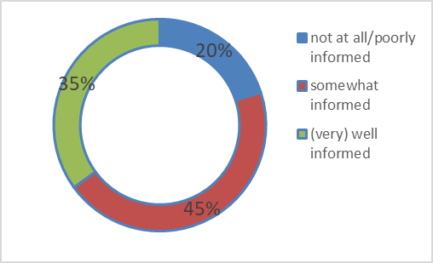
Overall perceived information about sustainability
- Highest percentage of (very) well informed for “food”: 41%

- Lowest percentage of (very) well informed for “purchase of products…”: 32%

- Those who feel overall (very) well informed score higher (56) in the CSBI than those who feel not at all/poorly informed (43)

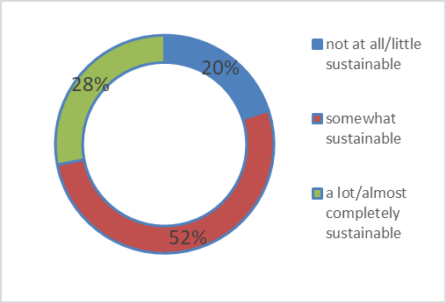
- For “waste management”, the percentage of those with a behavior a lot/almost completely sustainable is the highest: 46%

- For “purchase of products”, the lowest: 28%

- Those who perceive themselves as behaving more sustainably score higher (60) in the CSBI than those with a lower perception of sustainability in the own behavior (36)

Perceived sustainability of the own behavior

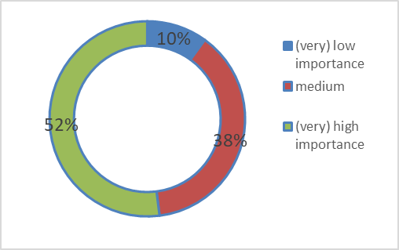
- Highest percentage of (very) high importance for “water and energy…”: 57%

- Lowest percentage of (very) high importance for “travel and mobility”: 41%

- Those who attribute a (very) high importance score higher (58) in the CSBI than those who attribute a (very) low importance (33)

Importance attributed to a personal sustainable behavior

Most important barriers to have a (more) sustainable behavior by dimension
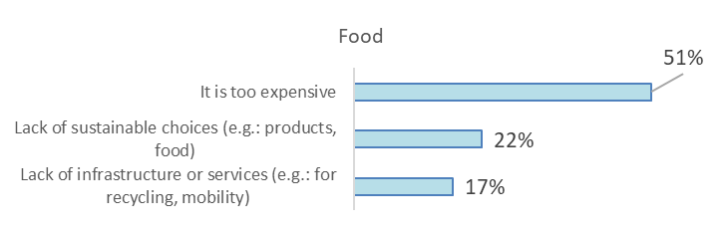
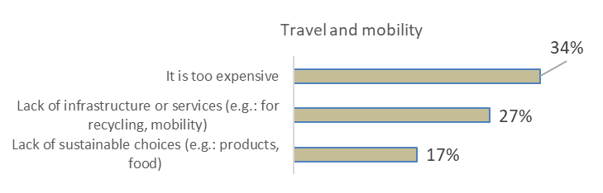

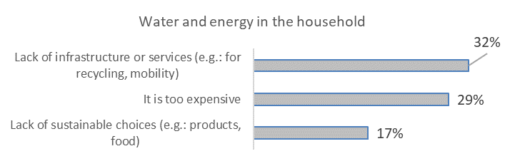

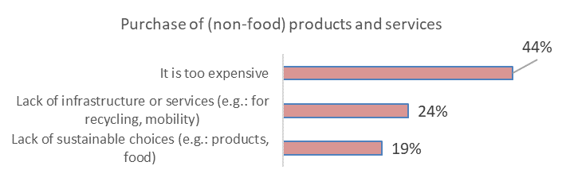

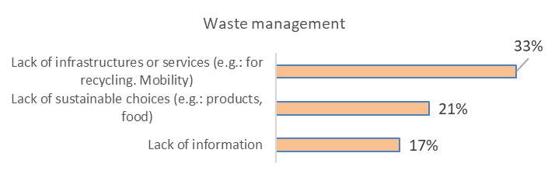

UK
CSBI results
The UK obtains the following scores in the CSBI
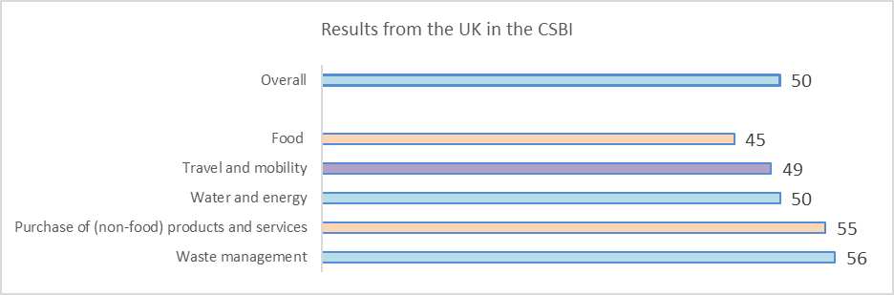
Above the average
On the average
Below the average

The UK scores on the average overall and above the average in travel and mobility. The most important variable for explaining the differences is age. The most important variable for explaining the differences is educational level. Respondents with a high educational level and a very comfortable/ comfortable/ very difficult financial situation score the highest in the CSBI (54). Respondents with a medium/low educational level score the lowest in the CSBI (48).

Below some relevant data on the behavior of the British by dimension:

- 2% of respondents describe themselves as vegan and 7% as vegetarian, whereas 42% eat animal products without trying to reduce its consumption

- 25% follow the behavior of trying to reduce food waste “almost completely”. On the contrary, 13% do not follow this behavior “at all” or “only little”

- 16% of respondents follow the behavior “mainly walking, use the bicycle and/or public transport in daily mobility “(almost) completely”

- 42% try to avoid flying “a lot” or “almost completely”
- 18% consider that they have, almost completely, a well insulated home

- In relation to having energy saving habits in the household, 3% follow this behavior “not at all” and 10% “little”
- 15% reduces/avoids overconsumption “almost completely”, whereas 20% “not at all” or “little”

- 48% prefers products that are of better quality, long lasting, and that can be repaired (“almost completely”+ “a lot”)

- 21% follows the behavior reusing products as long as possible “almost completely”

- For repairing products as much as possible instead of buying new ones, 25% do it “not at all” or “little”, whereas 14% “almost completely”

Importance attributed to dimensions and behaviors: comparisons
The following graph shows the importance (position) attributed to the dimensions included in the research in relation to their impact on sustainability: by British respondents and in the survey overall and by experts in the DELPHI research:
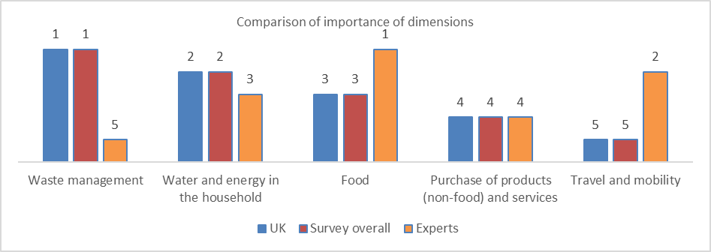

British respondents consider “waste management” as the most important dimension, followed by “water and energy in the household”, “food”, “purchase of products…” and “travel and mobility”. There are no differences whatsoever between British respondents and the survey overall.

However, British respondents differ significantly from expert’s opinion. Most important differences:

- “Waste management” is the most important dimension for British and the least important for experts

- “Travel and mobility” is the least important for British and the second for experts. Italians consider that “not having a car” is the least important behavior for the dimension, whereas for experts is the third; only 27% of British consider this behavior of “(very) high importance” for sustainability

- “Food” takes the third position in importance for British, whereas for experts is the most important dimension in relation to its impact on sustainability. British consider that the behavior “following a plant-based diet” is the least important, whereas for experts is the most important; 41% of Britsh consider it of “(very) low importance” for sustainability

Perceived level of information, sustainability of the own behavior and importance attributed to having a sustainable behavior

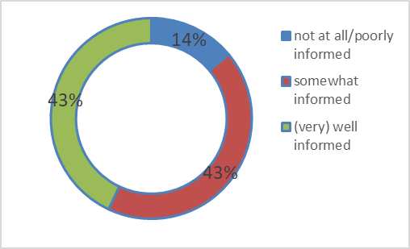
Overall perceived information about sustainability
- Highest percentage of (very) well informed for “food”: 50%

- Lowest percentage of (very) well informed for “purchase of products…”: 38%

- Those who feel overall (very) well informed score higher (57) in the CSBI than those who feel not at all/poorly informed (38)

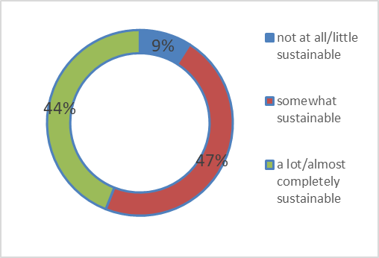
- For “waste management”, the percentage of those with a behavior a lot/almost completely sustainable is the highest: 54%

- For “purchase of products”, the lowest: 37%

- Those who perceive themselves as behaving more sustainably score higher (59) in the CSBI than those with a lower perception of sustainability in the own behavior (33)

Perceived sustainability of the own behavior

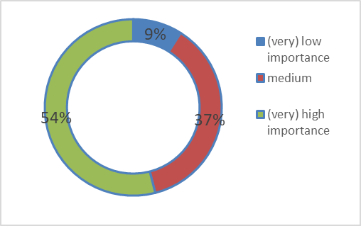
- Highest percentage of (very) high importance for “waste management”: 61%

- Lowest percentage of (very) high importance for “travel and mobility”: 43%

- Those who attribute a (very) high importance score higher (58) in the CSBI than those who attribute a (very) low importance (33)

Importance attributed to a personal sustainable behavior

Most important barriers to have a (more) sustainable behavior by dimension
